Amino Acids List

AA Name | Abbrev. |  | Structure |  | AA Name | Abbrev. |  | Structure
Alanine | Ala | A | 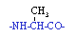 |  | Leucine | Leu | L | 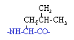
Arginine | Arg | R | 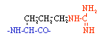 |  | Lysine | Lys | K | 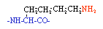
Asparagine | Asn | N | 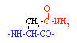 |  | Methionine | Met | M | 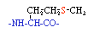
Aspartic acid | Asp | D | 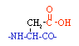 |  | Phenylalanine | Phe | F | 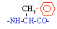
Cysteine | Cys | C | 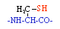 |  | Proline | Pro | P | 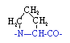
Glutamine | Gln | Q | 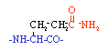 |  | Serine | Ser | S | 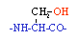
Glutamic acid | Glu | E | 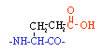 |  | Threonine | Thr | T | 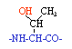
Glycine | Gly | G |  |  | Tryptophan | Trp | W | 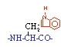
Histidine | His | H | 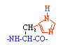 |  | Tyrosine | Tyr | Y | 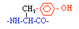
Isoleucine | Ile | I | 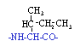 |  | Valine | Val | V | 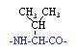

 | A  L  A | A  R  G | A  S  N | A  S  P | C  Y  S | G  L  U | G  L  N | G  L  Y | H  I  S | I  L  E | L  E  U | L  Y  S | M  E  T | P  H  E | P  R  O | S  E  R | T  H  R | T  R  P | T  Y  R | V  A  L
acidic (negative) |  |  |  | D |  | E
basic (positive) |  | R |  |  |  |  |  |  | H |  |  | K
charged |  | R |  | D |  | E |  |  | H |  |  | K
neutral | A |  | N |  | C |  | Q | G | H | I | L |  | M | F | P | S | T | W | Y | V
hydrophobic | A |  |  |  |  |  |  | G |  | I | L |  | M | F | P |  |  | W | Y | V
Hydrophilic (polar) |  | R | N | D | C | E | Q |  | H |  |  | K |  |  |  | S | T

*Amino acid structures from www.ionsource.com
Codon List
Translation from RNA to Protein

