RasMol Training Section III:

Designing a Model to be Built on the Rapid Prototyping Machines

Through this section of the RasMol Training Guide, you will become familiar with the commands needed to design a model that will be built on the rapid prototyping machine. As you become more comfortable using RasMol, this section will enable you to take the next step and be able to become a model designer.

In this section, you will learn how to
- Select an appropriate display format to use in your model design
- Add monitor lines for structural support
- Use Boolean operators
- Add hydrogen bonds within the beta sheet
- Remove “triangle bonds” within beta sheets
- Add sidechains to create a “clean backbone”
- Determine the appropriate sizes for Z corporation printed models
- Select appropriate colors to be used for the Z corporation printer

Model Design

1. How do you choose which type of display format to use in your model design?
- This is a common question that is asked by model designers. And the answer to this question is another question: “What is the story that you are telling with your model?”
- If your story is focused on a particular active site within the molecule, then perhaps the alpha carbon backbone model displaying key active site amino acid sidechains is the best display format to choose. If your story is focused on how two subunits interface at the surface, then perhaps the spacefill format is the best choice. Ultimately the choice is yours. In Section I, there is a table highlighting the advantages and disadvantages of each display format. This may assist you in deciding which format is the best for telling your story.
- The important point to remember is that no one model will tell every aspect of the story. Using RasMol in combination with the physical model will assist you in telling multiple aspects of your story.
- The CBM will build models in the spacefill format, wireframe and the alpha carbon backbone format. Models in the alpha carbon backbone format can have sidechains and heterologous groups displayed. We currently do not have the ability to build models in cartoon, ribbons or strands format.

2. Monitor Lines: What are they and where to place them
- When a model is built on the rapid prototyping machine, it is done through a layering system. A layer of powder 1/1000th of an inch thick is spread out. This powder is impregnated with droplets of binder with ink (Z corporation printer) or scintered together with a laser (SLS machine). At the end of the production time, the loose powder not incorporated into the physical model is vacuumed away. During the build time, there needs to be support within the model in order to withstand the additional pressure that accumulates as the powder builds up. Hence, monitor lines are added within the model for support.

- How do you know where to place Monitor Lines?
  - Monitor lines are NOT needed:
    - Within Beta Sheets
      - If a molecule has beta sheets within the structure, the presence of the hydrogen bonds within these sheets will provide very good support. Therefore, you do not need to add monitor lines within beta sheets.

    - Within Alpha Helices
      - Alpha helices are very stable internally, therefore, neither hydrogen bonds nor monitor lines are needed within the helix structure itself.

  - Monitor lines ARE needed:
    - Monitor lines will be needed in regions of the protein that look like they might be able to squeeze together.
      - A good example of this: If you look at the image below on the left, you can see the alpha helices are colored in blue. These helices are stable from top to bottom, as mentioned above, but they do have the tendency to flex from side to side. (See regions indicated by yellow brackets in the figure below, which is based on 1TIM.pdb.) Due to this flexibility from side to side, monitor lines are needed to stabilize the helices.
      - By adding monitor lines in between the helices, as shown in the figure below as yellow bars (and pointed to by the arrows), you will increase the stability of this protein and prevent the flexing of the helices.
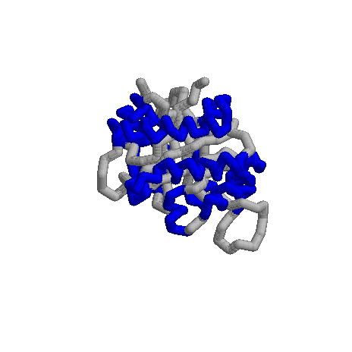
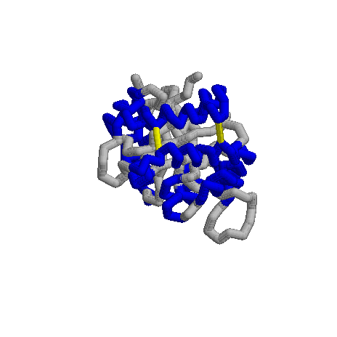
Before monitor line addition
After monitor line addition

      - To determine if the model will need monitor lines, we do the “squeeze test.”
        - The “squeeze test” refers to the ability to potentially squeeze a portion of the molecule together. When you look at the image of the molecule on the computer screen, can you see potential regions where you might be able to squeeze the model together, or potential flex points? If so, then you need to add monitor lines to this region to prevent this “squeezing” from occurring.
      - We recommend that you add monitor lines at the “top” and “bottom” of the helix in order to anchor the helix. If the helix is exceptionally long, then adding a monitor line in the middle will further stabilize the helix.

    - Monitor lines are also needed where there are large loops and turns within a molecule that could potentially be sites that need additional support.

In the image on the left, the blue arrows indicate a loop that would need a monitor line to stabilize the loop. On the image on the left, the blue arrows indicate the positions in which yellow monitor lines have been added to stabilize the loops.

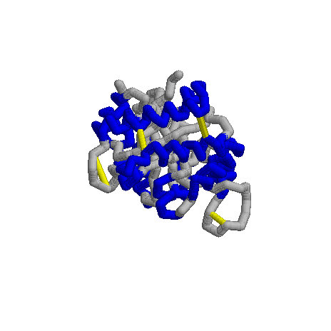
Before monitor line addition
After monitor line addition

    - Monitor lines should also be used to connect heterologous groups, such as the zinc ion in a zinc finger, as shown in the figure below. (This figure is based on 1ZAA.pdb, which was used in Section I of the training guide.)

      - If heterologous groups are not connected with monitor lines, they will be built as a separate piece. For example, in the figure to the left there are not currently monitor lines attached to the zinc ion, so the protein component (gray) would be built as one unit and the zinc ion (green) would be a separate piece.
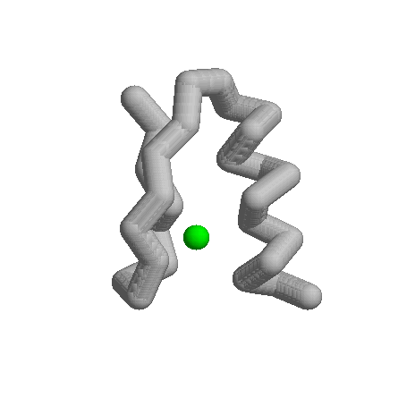
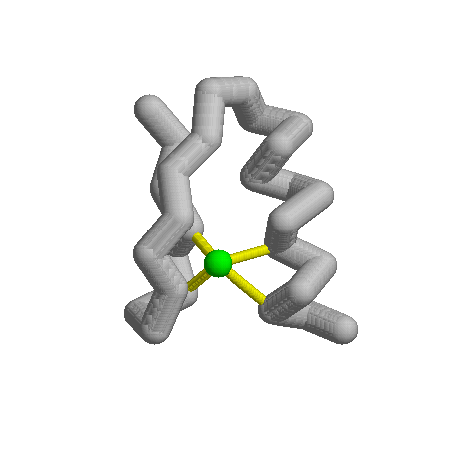

Zinc ion that is not attached with monitor lines.
Zinc ion that is attached with monitor lines.

    - Monitor lines are also needed to connect subunits if your molecule has multiple subunits. If you do not use monitor lines to connect the subunits, the molecule will build as separate subunits that are not connected.
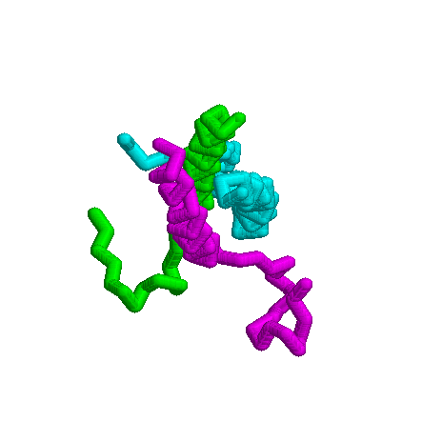
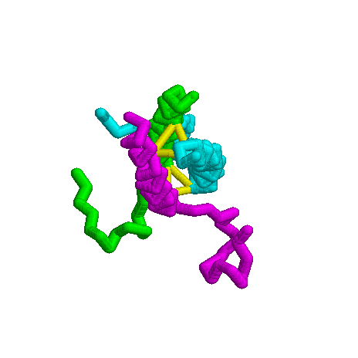
      - Below are two figures of fibrinogen, based on 1JY2.pdb, which has three chains, each a different color. The figure on the left does not have any monitor lines and if it were built in this fashion, it would be built as three separate chains. In the figure on the right, there are monitor lines (show in yellow and indicated by the arrows) that will hold the three chains together.

Before monitor line addition
After monitor line addition

- Final Note on monitor line placement:
Monitor lines are used to stabilize the molecule. Anywhere that you think that the molecule looks like it needs additional support, add a monitor line.

3. Adding monitor lines
- Monitor lines are added to the molecule by entering in a command in the Command Line window.
- To add the monitor line, you must first identify the atom numbers for the atoms between which you intend to draw the monitor line. To do this, move your mouse cursor over the atoms and click the left mouse button. This action will generate information in your command line window that will provide you with the atom identity, as described in Section I. The first number that is provided in that line of information is the atom number, and this is the number that you need in order to create a monitor line.
  - Once you have identified the two atom numbers between which you would like to have the monitor line exist, the next step is to enter the command to make a monitor line:
    - RasMol>monitor atom number atom number
      - Example: RasMol> monitor 656 8567
        - It is essential to put a space between the numbers.
        - It is also essential to use the atom number and not the amino acid number.
      - You will notice that monitor lines initially appear as a dotted line, just as the hydrogen bonds and disulfide bonds did (see Section II).
      - In RP-RasMol, to add dimension to monitor lines:
        - RasMol>set monitor 225
          - Please note that this feature is only available in RP-RasMol. You can create monitor lines in RasMol, but you can only add dimension to the monitor lines with RP-RasMol. To obtain a copy of RP-RasMol for academic purposes, please contact Tim Herman at herman@msoe.edu.
    - Once you have given the first monitor line dimension, you will not need to do this again. All future monitor lines will have the same dimension. All monitor lines will have the same dimension.
    - The monitor line command is similar to a toggle switch. If you decide that you do not like the position of the monitor line or if the monitor line is too long, you can simply re-enter the monitor line command (in the above example, RasMol>monitor 656 8567) and it will turn off the monitor line.
    - If you wish to turn ALL of the monitor lines off:
      - RasMol>monitor off
        - Please note that this command will turn off all of the monitor lines within the molecule. To turn off specific monitor lines, use the monitor command above.
    - A number will appear next to the monitor line and this number is the length of the monitor line in angstroms. A monitor line should not be longer than 9 angstroms. If the monitor line is longer than 9 angstroms, it is not stable and it defeats the purpose of being present to stabilize the molecule.

4. Coloring the Monitor lines
- When the monitor line initially appears, it will be the color of the atoms that the monitor line is connecting.
  - If the two atoms are the same color, then the monitor line will be the same color throughout the length of the monitor line.
  - If the two atoms are different colors, then the monitor line will be half one color and half the other color.
- To specifically color the monitor line (as opposed to the default setting described above):
  - RasMol>select all
  - RasMol>color monitor white
- It is essential that you include “monitor” within your command. If you forget to include the “monitor” within the command, you will color your entire molecule whatever color you have selected for your monitor color (in the above example, white).
- We recommend that you choose a light color for your monitor lines, such as white or light gray. Monitor lines are support structures and should not be the emphasis of your model. A bright or dark color will draw the user’s eye to that feature and that should not be the focus of your model.
- We at the CBM often color monitor lines and hydrogen bonds the same color (white). Some SMART Teams in the past have opted to color their monitor lines a different color from their hydrogen bonds to differentiate the two types of structural features. This is entirely up to the designers. Our only recommendation is to downplay the color (light colors) choice in order to prevent the focus from being on these structural features.

5. Boolean Operators
- You can link together RasMol commands by using Boolean Operator (And, Or, Not) in order to select very specific things in RasMol.

- Boolean Operators

A
B

  - OR (RasMol>select A or B)
    - Selects everything in both circles
  - AND (RasMol>select A and B)
    - Selects only that which is in the region that overlaps between the two circles
  - NOT (RasMol>select A not B)
    - Selects the region in A that does not overlap with B
- Practice:
  - Round #1
    - Select men and women
    - Stand up
      - NO ONE should have stood up (unless you are a hermaphrodite)
  - Round #2
    - Select men or women
    - Stand up
      - EVERYONE should have stood up because this selection process selects everyone who fits the category Men as well as everyone who fits in the category Women
  - Round #3
    - Select women and Wisconsin residents
    - Stand up
      - Only women who live in WI should have stood up

  - Round #4
    - Select men or those who are wearing black shirts
    - Stand up
      - All men should have stood up, as well as women wearing black shirts
      - Note that some may have fulfilled both aspects in that men with black shirts may be present.
- The use of Boolean operators is essential in RasMol in order to select specific portions of the molecule. For example, if you wish to select the sidechain of histidine 63:
  - RasMol>select his63 and sidechain
    - This command selects the atoms that meet both criteria: being a part of histidine 63 and an atom within the sidechain (as opposed to an atom within the backbone).
- As in math, operations that are placed within parentheses are performed first.
  - RasMol>select his63 and (sidechain or alpha)
    - This command will select the sidechain atoms as well as the alpha carbon atom of histidine 63.

6. Hydrogen Bonds
- As discussed in Section II, hydrogen bonds can be added with the command “Hbonds.” Since alpha helices are stable structures in terms of buildability on the rapid prototyping machines, please note that we do not recommend placing hydrogen bonds in alpha helices. We do, however, highly recommend placing hydrogen bonds within beta sheets. The placement of these bonds within the beta sheets stabilizes the structure.

- To add hydrogen bonds specifically to the beta sheets:
  - RasMol>select sheets
Triangle Bond
  - RasMol>hbonds 225
  - RasMol>set hbonds backbone
    - Note: If your molecule has multiple chains, you will need to be more specific with your command. Ie: RasMol>select *a and sheets

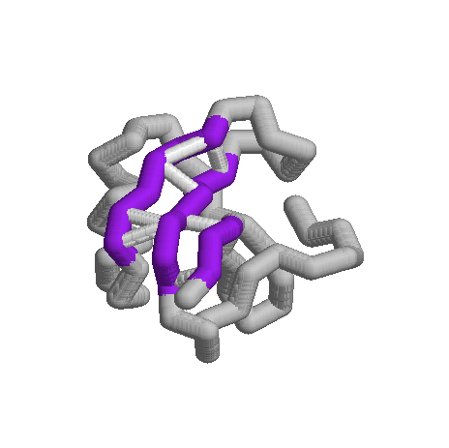
- You may notice that some hydrogen bonds may appear to look like “triangle bonds” in that they connect two alpha carbon atoms to create a triangle. The two amino acids will be N and N+2. For example: Amino Acid 6 and Amino Acid 8, or Amino Acid 55 and Amino Acid 57.

- These “triangle bonds” are not “real” and are distracting when we build the alpha carbon backbone models, and they do not add stability to the physical model. We recommend that you remove these bonds.

- To remove these bonds, select the amino acids and remove the bond.
  - RasMol>select 6 or 8
  - RasMol>hbond off
    - Note: if you molecule has multiple chains, you will need to be more specific with your command. Ie: RasMol>select *a and (his6 or arg8)

7. Adding Sidechains with a clean backbone
- If your story requires that you display specific amino acid sidechains to the model, we recommend that you do so in a way that only displays the sidechain atoms, rather than all of the atoms of the amino acid. In previous sections, we have simply selected the amino acid and displayed all of the atoms. In this section, we are going to use the Boolean operators to select just the atoms in the sidechain and display only these atoms.

- To select and display only the atoms of the sidechain of a specific amino acid:
  - RasMol>select his63 and (sidechain or alpha)
    - This command selects the amino acid (histidine 63), but limits the selected atoms to the sidechain atoms and the alpha carbon of that amino acid. It is important to select the alpha carbon atom in addition to the sidechain atoms because we need to attach the sidechain atoms to the alpha carbon. If we do not select the alpha carbon, the sidechain will build as a separate unit from the rest of the molecule

  - RasMol>wireframe 225
  - RasMol>spacefill 275
    - These two commands together will generate a ball and stick appearance. You can enter just the wireframe command and create a “sticks” appearance, but you cannot enter just the spacefill command. If you enter just the spacefill command, the atoms will be displayed as just little spheres and the spheres will not be connected to one another. It is therefore imperative to add the wireframe command in order to connect the spheres together.

- If you just select the amino acid with command of “select his63”, you will select all of the atoms within the amino acid and will generate a “bumpy backbone.” Unless the backbone atoms of the amino acid (the amino nitrogen or the carbonyl oxygen) play a specific role, then we generally do not recommend displaying these atoms on the model. It is typically (although not always) the sidechain that has the specific chemical role within the molecule and plays the key role within your story. Therefore, this should be the part that is displayed within your molecule.
- If you need to selectively display the backbone atoms and not the sidechain atoms, see number 10 for additional special design commands.

8. Use of Command Window versus the Pull-Down menu for designing molecules
- We recommend that you use the command line window exclusively when designing your model, rather than using the pull-down menu in combination with the command line window.
- When using the command line window, you can create your model in a step-by-step fashion and you can selectively add or subtract features.
- The pull-down menu is limited in terms of what features can be displayed. For instance, you cannot selectively display sidechains through the pull-down menu. Combining the two command features can potentially cause problems in your design work as the pull-down menu options will could potentially over-write any designs that you have created through the command line window.
- To illustrate this feature, proceed through the follow exercise:
  - Open 1A3N.pdb
  - RasMol>restrict *b
  - RasMol>backbone 300
  - RasMol>wireframe off
  - RasMol>select helices
  - RasMol>color red
  - RasMol>select his63 and (sidechain or alpha) and *b
  - RasMol>wireframe 225
  - RasMol>spacefill 275
  - RasMol>select his92 and (sidechain or alpha) and *b
  - RasMol>select *b
  - RasMol>color cpk
  - Use the pull-down menu to choose Cartoon
    - Notice how the wireframe/backbone combination disappeared and was replaced entirely by the cartoon format.
    - More importantly, notice that the sidechains that you selectively displayed are no longer present. The pull-down menu has overwritten what you have created using the command line window.
  - Return to the command line window
  - RasMol>wireframe 225
    - Notice how you added the wireframe to the cartoon, rather than replacing it.
  - Return to the command line window
  - RasMol>backbone 300
    - Notice that you have added the backbone on top of the pre-existing cartoon and wireframe format.
    - In order to remove the cartoon feature, you will need to turn this off.
  - RasMol>cartoon off
- If you alternate between the pull-down menu and the command line window, you may end up with an odd combination of features, or you may lose work that you have you created within the model. This can be very frustrating, especially if you have spent time designing your model, all to be lost within a few seconds of using a pull-down menu command.
- For this reason, we recommend that you exclusively use the command line window for your design work.

9. Recommended values and colors to use within your model
- During the summer of 2005, the Center for BioMolecular Modeling and 3D Molecular Designs purchased a new Z Corporation printer. This new printer is more accurate with its printing and we have developed a new guideline for recommended values for designing a model. These are the design values that we recommend using if your molecule is 200-1000 amino acids in length. If your molecule is smaller or larger, please contact us for other recommended values.
  - Backbone 300
  - Spacefill 275
  - Wireframe 225
  - Monitor lines 225
  - Hydrogen bonds 225
  - Disulfide bonds 225
- We also have recommendations with respect to colors:
  - The printer is a CMY printer (cyan, magenta, yellow)
    - Therefore, cyan, magenta and yellow are considered to be the “pure” colors and will be the brightest.
    - All other colors will be a mixture of these three colors.
    - Secondary colors created by mixing any two of the primary colors are also a good color choice. Ie: cyan and yellow will give you green.
    - We will NOT print black.
  - Colors should highlight features. In your model, the colors that “jump out at you” should be on the features that you want to emphasize in your model to assist in telling a specific story.
    - For example, you would not want your monitor lines to be colored magenta and everything else colored a light color, since the monitor lines will become the focal point of your model and the monitor lines should be the least important feature of your model. You should reserve the bright colors, like magenta, for the important features, such as the helices or the sidechains of the active or binding site.

10. Additional Design Commands
- Selecting a specific atom
  - If you would like to specifically select an atom, you would use your mouse to identify the atom number, (see Section 1 for further information on how to do this) and then you would use the “select” command and the “atomno=” command, which is needed to identify the atom number, rather than the amino acid number.
    - If a number is entered into the prompt line, the default assumption is that the number is the Group Number (such as the amino acid number). If you wish to specifically select the atom number, you need to designate the number as the atom number.
      - RasMol>select atomno=376
        - This command will select the atom within the molecule that is numbered 376.

- Selecting a region within the molecule
  - You can select a region within the molecule by selecting the range of amino acids or a range of atoms
    - Range of Amino Acids
      - If you would like to select amino acids within a range, you can do so by entering the following command:
        - RasMol>select #-$
          - The # indicates the number of the first amino acid of your range and the $ indicates number of the last amino acid of your range.
        - For example:
          - If you wished to select amino acids 4-31 of the molecule, you would enter the following command:
            - RasMol>select 4-31
            - Note: If you need to select 4-31 of a particular chain, you need to include that within your selection criteria.
              - RasMol>select *a and (4-31)
    - Range of Atom Numbers
      - If you would specifically like to select a range of atom numbers, you can do so by entering the following command:
        - RasMol>select (atomno>=___) and (atomno<=___)
          - the underline region is where you would insert the specific atom number of your range
        - For example:
          - If you would like to select all of the atoms between 436 and 862:
            - RasMol>select (atomno>=436) and (atomno<=862)

- Turning the monitor labels off
  - With each monitor line added to the molecule, there will appear a number next to the line that designates the length of the monitor line in angstroms. If you are exporting this image, the numbers may clutter the image. Or, if there are several monitor lines, the numbers may hinder your viewing of the molecule. You may then wish to remove the labels from the molecule.
  - To turn off the labels, enter the following command:
    - RasMol>set monitor off
  - Note: Make sure that you have the word “set” included in the command. If you enter the command “monitor off”, all of the monitor lines that you have added to the molecule will be turned off.
- Repeating a command
  - By pressing the up arrow key on the keyboard, the previous commands that you have entered into the command line window will be repeated.
- Selecting specific types of atoms
  - If you wish to select a subset of atoms, such as all of the alpha carbons, you can do so by using the “*” command and the 1 or 2 letter codes for the different atoms within the molecule
  - For example, if you wished to select all of the alpha carbons:
    - RasMol>select *.ca
      - The “ca” refers to the alpha carbons

Atom in Backbone | RasMol Designation
Nitrogen | n
Alpha Carbon | ca
Carbonyl carbon | c
Carbonyl oxygen | o

Conclusions

At the end of this section, you should feel comfortable designing a molecule that could successfully be built on the Z Corporation machine. To this end, you should be comfortable with the following items:
- Adding hydrogen bonds
- Removing triangle bonds
- Adding monitor lines
- Adding sidechains with a clean backbone
- Using “good” colors and “good” values

Any comments/suggestions should be sent to Shannon Colton at colton@msoe.edu

