RasMol Training Section II:

Understanding the Protein Data Bank and

More Specific Commands within RasMol

In Section II of the MSOE Center for BioMolecular Modeling RasMol Training Guide, the focus is to learn about the Protein Data Bank, the worldwide repository for the crystal structure files, and to learn additional specific commands within RasMol. Section II will emphasize how to use RasMol in a more sophisticated manner using these specific commands. Mastering the material in this section will prepare you for further understanding of how to use RasMol and using RasMol in the Protein Modeling Challenge in the MSOE Center for BioMolecular Modeling sponsored event in the Science Olympiad (www.rpc.msoe.edu/cbm/scienceolympiad). In this section, we will focus on how to
- Use the Protein Data Bank (www.pdb.org)
- Save your work on RasMol by generating script files
- Open script files in RasMol
- Edit script files
- Center molecules in RasMol
- Select whole fields within RasMol
- Restrict subsets of the molecule within RasMol
- Add and remove hydrogen bonds within the molecule in RasMol
- Add and remove disulfide bonds within the molecule in RasMol

Part I

1. Protein Data Bank
- The PDB (www.pdb.org) is the single worldwide repository for the processing and distribution of 3-D structure data of large molecules of proteins and nucleic acids.
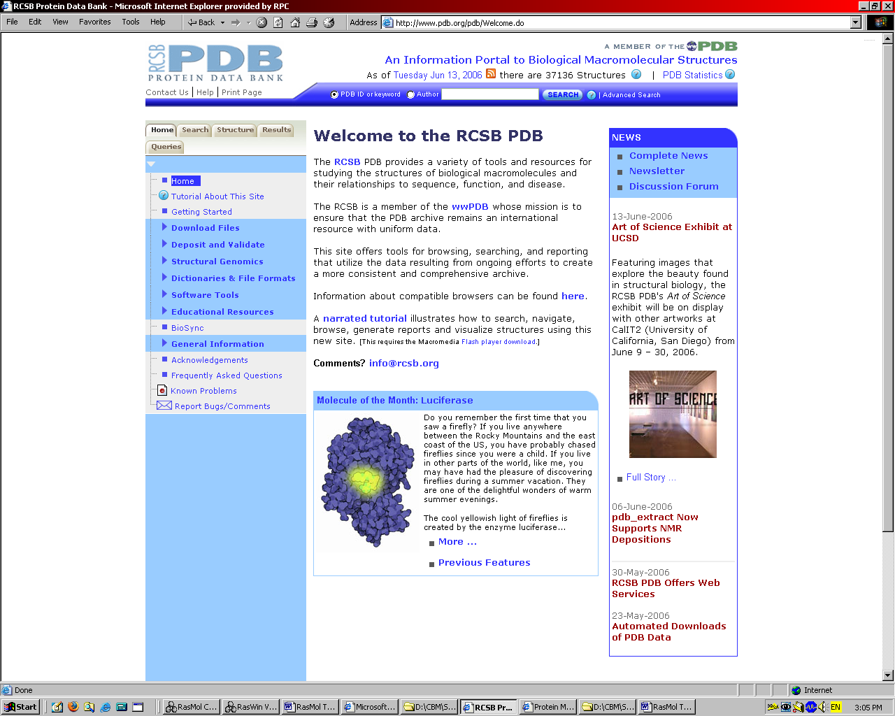

- As of 25 September 2008, there are 53,263 structures within the PDB.
- Resources within the PDB:
  - Molecule of the Month http://www.pdb.org/pdb/static.do?p=education_discussion/molecule_of_the_month/index.html
  - PDB Newsletter by Gary Graper describing the Science Olympiad http://www.rcsb.org/pdb/general_information/news_publications/newsletters/2005q2/education_corner.html
  - PDB Newsletter (read about the New Jersey Science Olympiad Protein Modeling Challenge Event sponsored by the PDB) http://www.pdb.org/pdb/static.do?p=general_information/news_publications/news/news_2006.html#20060404
  - Educational Resources http://www.pdb.org/pdbstatic/education_discussion/educational_resources/education_flyer.pdf

- Each entry within the PDB contains several pieces of information:
  - Structure summary page
    - PDB Structure ID number
      - This 4 letter/number ID is a unique identifier that is assigned to the crystal data file upon deposition into the database.
    - Title
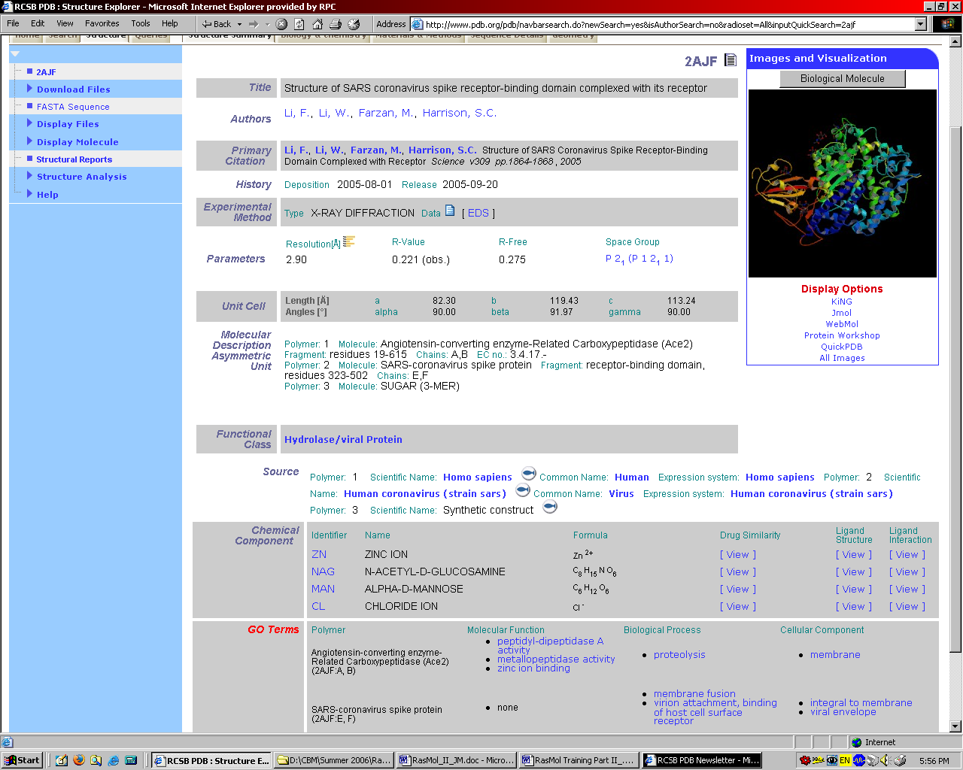
      - Title of the PDB file
    - Authors
      - These are the researchers who were involved with the crystallization of the molecule. Note: The senior author or principal investigator is usually the last author in science publications.
    - Primary Citation
      - The journal article that accompanies the PDB file; excellent research resource for understanding the function of the molecule.
    - History of deposition and release
      - The date that the molecule was deposited into the PDB and the date the information was released to the public.
    - Method of structure determination
      - The method that was used to obtain the structural data (ex: NMR, X-ray diffraction).
    - Resolution at which the molecule the structural data was collected
      - How accurate the data is; the smaller the number, the better the data.
    - Molecular Description
      - This will tell you the number of chains within the molecule and the chain identity; for example in the hemoglobin file (1A3N.pdb), the chains A and C are the alpha-globin molecules and chains B and D are the beta-globin molecules.
    - Functional Class of the molecule
      - What type of molecule is it? (Ex: a toxin, an enzyme)
    - Source of the molecule
      - From which species was the molecule isolated? (human, bacterium, virus, mouse)
    - Chemical component
      - In this section, you will be able to determine if there are any heterologous groups that were crystallized with the molecule. Not all PDB files will have this section.
      - The 2-3 letter identifier used to designate the chemical components contained within the file listed are recognized by RasMol.
        - For example, if this section stated that there was NAG (N-acetyl-glucosamine) contained within the molecule, RasMol would recognize “NAG” and you could therefore “select NAG” and RasMol would be able to select the atoms within that chemical component of the PDB file.

  - Sequence Details
    - This section of the PDB file provides specific sequence information as well as secondary structure information about the molecule.
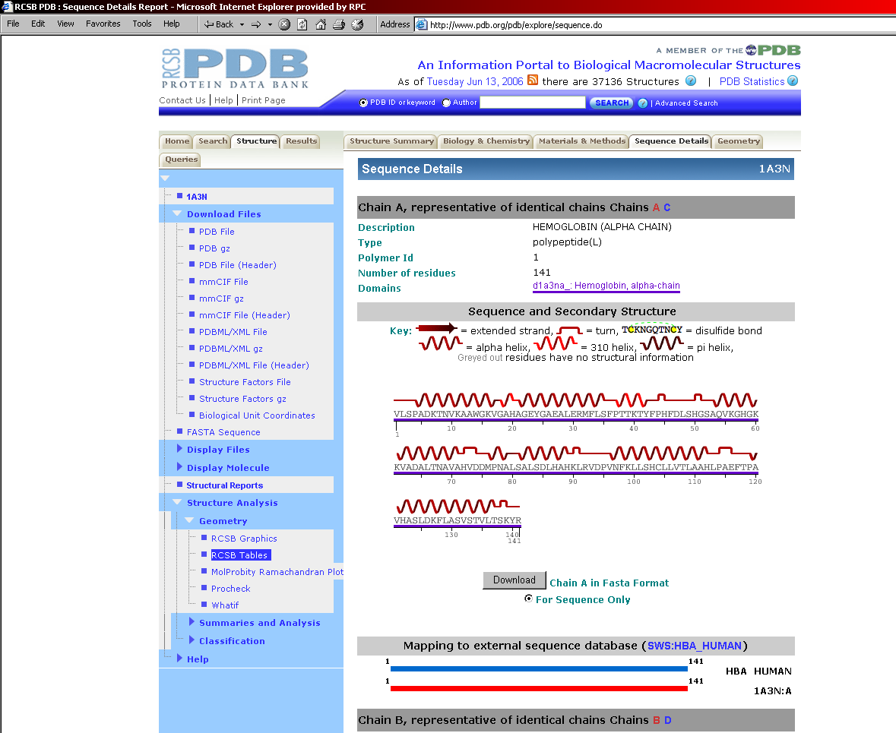
    - In this section of the PDB file, you can identify where within the protein the alpha helix or beta sheets are located, as well as the amino/carboxy termini, which are the first and last amino acids of the protein, respectively (for more information about identifying these amino acids, please refer to number 13 within this section of the training guide).

Amino terminus; first amino acid in protein
Carboxy terminus; last amino acid in protein

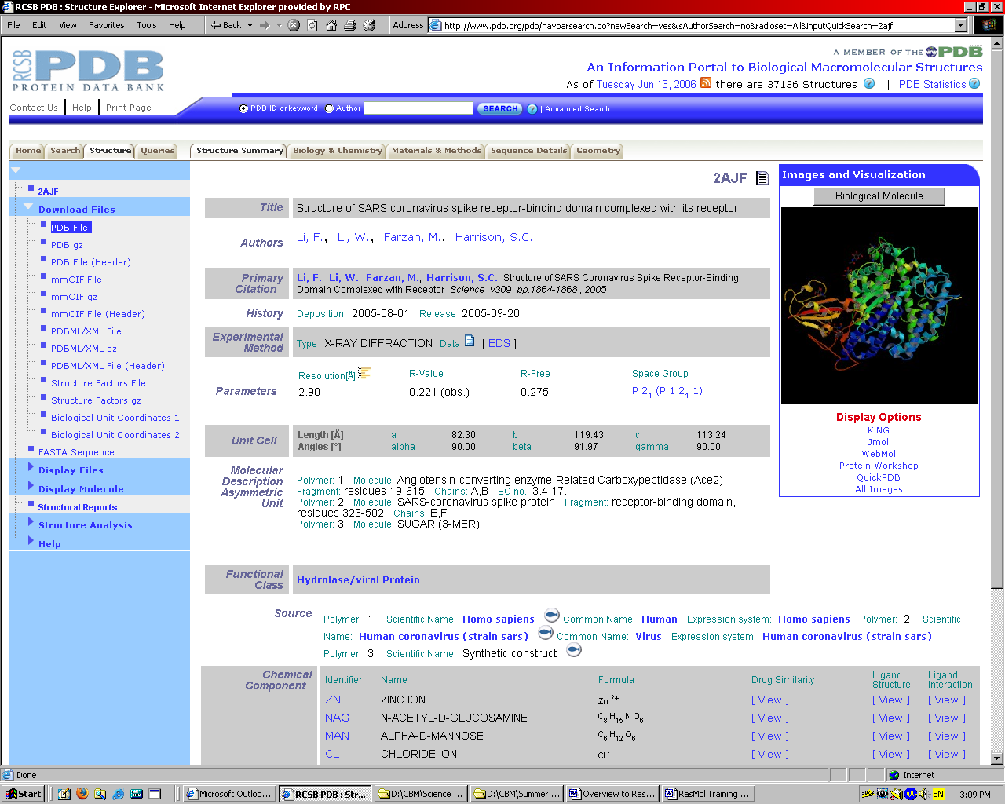
Search Field
Practice searching:
- In the search field, enter “aquaporin” and click on “search.”
  - This search will bring back a search result that gives 18 structure hits.
  - The PDB will list all 18 of these structures.
- If you enter “hemoglobin” into the search field, you will see that there are 362 structure hits.
  - If you do a broad inquiry like this one, you will need to look through the structures to see which one meets your requirements, for example:
    - Human versus mouse
    - Mutant versus “normal”

2. Search the Protein Data Bank
- One of the features of the PDB is the ability to search the database for files. You can search using key words or authors by entering these terms in the search box, highlighted in red in the figure below. Or, if you already know the PDB structure ID number, you can enter that number in the search field. After you have entered the search terms in the field, hit enter or click on the “search” button to the right of the search field.

3. Download a PDB file
To save a pdb file, click on “Download Files,” which is located on the left navigation bar
- 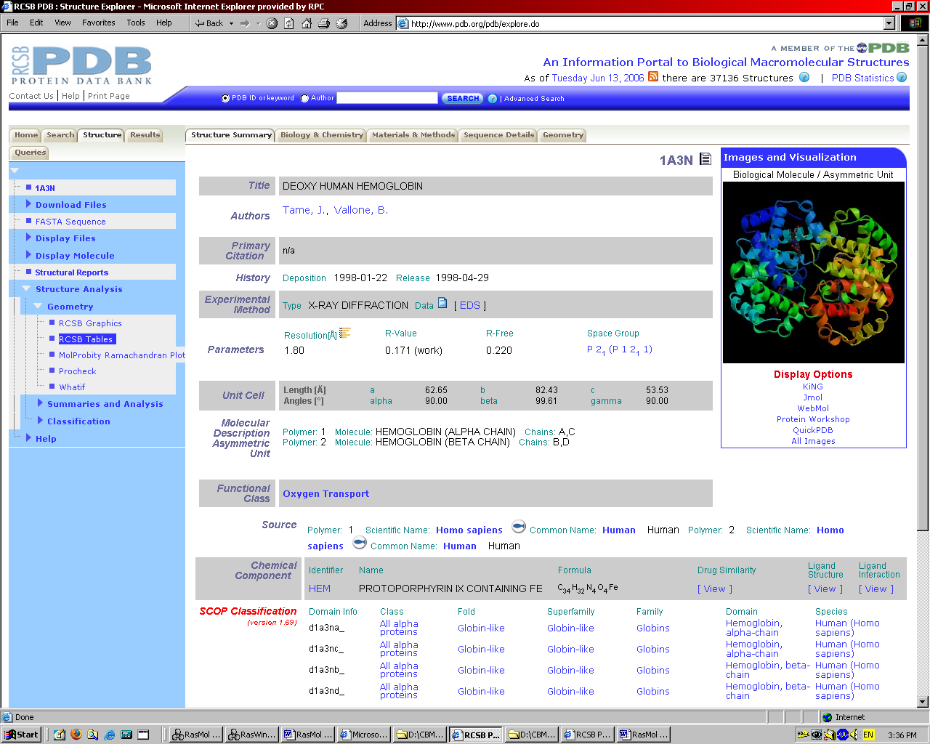
This will create a pull-down menu that will give you several options:

Download Files

PDB File

PDB gz

PDB File (Header)

mmCIF File

mmCIF gz

mmCIF File (Header)

PDBML/XML File

PDBML/XML gz

PDBML/XML File (Header)

Structure Factors File

Structure Factors gz

Biological Unit Coordinates

FASTA Sequence

Select this option. By clicking on this link, it will bring up a “File Download” window. At this point, you click on the “Save” option and select which folder you would like to save the PDB file on your computer.

Remember our recommendation of organizing your work to include the PDB file and a copy of RasMol in a separate folder for each project on which you are working.

This organization will become important as you save your work (generate script files), which will be discussed in number 8 in this section of the training guide.
3. Download a PDB File
To save a PDB file, click on “Download Files”, which is located on the left navigation bar.

4. Searching the PDB and Reading a Structure Summary Page (practice)
- Search the database for “SARS spike receptor binding domain coronavirus protein”
- 8 structures should appear (as of 25 September 2008)
- Look for the one authored by Li et al and click on the PDB structure ID number
- You should arrive at the structure summary page for 2AJF.
- Use this structure summary page to answer the following questions about the PDB file (answers are at the end of this section):
  - Who are the authors of the PDB file?
  - In which journal was the primary citation published?
  - On what date was the file deposited into the PDB?
  - How many chains are in this file?
  - Are there any heterologous groups within this PDB file? If so, which ones?
  - From what source was this molecule isolated?

5. Download a File (practice)
- We are now going to work with the potassium channel as our model PDB file.
  - Create a folder labeled “RasMol Training”. Within this folder, create a Kchannel folder.
  - Place a copy of RasMol in this folder.
  - Search the PDB for 1J95
  - Download 1J95 to the K Channel folder on your computer
    - This organization will be especially important within this section of the guide.

6. Opening a PDB file (review)
(for more information see Section I)
- Opening PDB files
  - Double-click on the RasMol icon within your folder.
  - Arrange both windows on your screen.
  - Go to the file menu.
  - Click on “Open.”
  - Click on the appropriate PDB file (open 1J95).

7. A little review from the previous section
- How do we do the following items?
    - (answers at the end of this section)
  - Change Background to white
  - Change display formats
  - Change colors
  - Highlight the helices as red

8. Save your work – Creating a Script File
- RasMol has a feature that allows for you to save your work. In order to save you work, you will generate a script file.
  - RasMol> save script filename.spt
    - Example: RasMol> save script Kchannel.spt
      - We recommend saving multiple versions of your model design as you work.
        - For example, as you progress through your design, save Kchannel1.spt, Kchannel2.spt, Kchannel3.spt, etc. This allows for you to return to previous files, in case you accidentally save a file that you did not like, or if you make a mistake. There is not an “undo” command in RasMol.
        - Through saving multiple versions of your work, you can return to a previous version if you accidentally do something to your molecule that you do not like, or if you accidentally lose your work.
        - As with any important document, save your work often!
    - Please Note that it is very important to include the “script” and the “.spt” components to this command.
      - If you enter the command with “save filename.spt”, you will create a PDB file and NOT a script file.
      - If the save command does not include these items, a script file will NOT be created. If you exit RasMol before a proper script file has been created, all work that you have done will be lost.
  - Once you have entered this command, you have saved your work.
  - Check your folder for your newly created script file.
    - If you have organize your work in such a way that there is a copy of RasMol and the PDB file in the same folder, and have launched RasMol from this folder, the RasMol program will automatically save the script file to this folder.

9. Opening a script file
- To open a script file:
  - First, launch the copy of RasMol in your Kchannel folder.
  - In the command line window, enter the command:
    - RasMol>script filename.spt
      - Example:
        - RasMol>script kchannel12.spt
  - This should open your version of the molecule in the molecular visualization window.

10. Practice saving/opening a script file
- Open the Kchannel PDB file 1J95 using the pull-down menu.
  - RasMol>select all
  - RasMol>backbone 300
  - RasMol>wireframe off
  - RasMol>color white
  - RasMol>select helices
  - RasMol>color cyan
  - RasMol>select hydrophobic
  - RasMol>color yellow
  - RasMol>save script kchannel.spt

- At this point, we have created a script file, or saved your work. We have generated an image in which the helices are colored cyan, except where there are hydrophobic amino acids.
  - Question: Why are there so many hydrophobic amino acids located on the outside of this protein when we have learned that hydrophobic amino acids are typically located buried within the molecule, away from the aqueous external environment? (answer at the end of this section)
- Okay, now that we have generated a script file, let’s erase the image from the screen so that we can open the script file
  - RasMol>zap
  - RasMol>script kchannel.spt

- Did your original file open?
  - If so, congratulations, you have created your script file and opened your script file successfully! If not, go back and see where you made your mistake before continuing.
    - Did you have the “save”? Did you have the “script”? Did you have the “.spt”?
    - If the script file did not open, either the command was not entered correctly in the command line window, or the file was saved in a different folder location.

11. Editing your script file
- Any time that you generate a script file, RasMol will place the script file in the folder that RasMol was originally launched. This is the reason that we recommend organizing your work so that each molecule you are exploring has its own folder with a copy of RasMol and the PDB. Each time you generate a script file, it will then be saved in that folder.
- When you save your script file, a specific pathname will be generated and saved within the script file directing RasMol to look within a specific folder for that particular PDB file.
- There may be times in which you work on one computer and wish to transfer your file to another computer. If you simply copy or move the script file to a new computer or a new folder and try to open the script file using the command described above, RasMol will be unable to locate the PDB file because it will be looking for the PDB through the specific pathname that was generated when the script file was generated.
- This can be circumvented by editing the script file.
- To edit your script file, open your script file using a word processing program such as Notepad or Wordpad. We recommend that you DO NOT use MS Word for this process.

This is what you will see when you open your script file:

#!rasmol -script
# File: kchannel.spt
# Creator: RasMol Version 2.6

zap
load pdb "D:\CBM\Summer 2006\RasMol Training 2006\RasMol Training II\1J95.pdb"
background [255,255,255]
set ambient 40
set specular off

- The text in blue is the pathname and tells RasMol the folder location of the PDB file. If you wish to use this script file on other computers, you will want to edit this line in the script file so that you can open the script file on any computer. In order to open this file on any computer, simply change the pathname to what you see in the text box below in red:
#!rasmol -script
# File: kchannel.spt
# Creator: RasMol Version 2.6

zap
load pdb “.\1J95.pdb"
background [255,255,255]
set ambient 40
set specular off

- By changing the pathname to “.\1J95.pdb”, you are making a generic pathname (ie: load the PDB file located in “this” folder). If you have a folder on the new computer with RasMol, 1J95.pdb and the script file, you will be able to open the script file. This generic pathname will work, only if the folder contains RasMol, the PDB file and the script file. You must launch RasMol from this folder for the generic pathname to work.
- After you have saved your script file and you know that you are going to be changing computers, we recommend changing the pathname. This is especially important if you plan to email the sript file amongst team members. Once you change the pathname, you will not need to do it again.

12. RasMol Commands
- Section I of the MSOE CBM RasMol Training Guide introduced you to the basic commands within the RasMol program. We will now present additional commands to further develop RasMol design skills.

- The “*” Command
    - The * key within RasMol is wild card for a whole field in which you can designate all atoms within a field.
      - For example, if you wanted to select all of the atoms within Chain D of 1J95.pdb, you would type:
        - RasMol>select *d
          - This command would then select all of the atoms within chain D of the K channel.
- Restrict
    - This command allows you to restrict your view of the molecule to specific to portions of the molecule dictated by you. You can restrict to specific chains, specific amino acid sections or specific features.
      - For example, if you wish to only look at chain D in the K channel, you can type:
        - RasMol>restrict *d
          - Notice that we have used the “*” command to select all of the atoms in Chain D and we have used the “restrict” command to restrict our viewing of only the atoms in Chain D.
          - Note that with the restrict command, all of the other parts of the molecule have disappeared from view. The other atoms are still in the PDB file, but you have “restricted” your view to the specified region.
- Center
    - The “center” command will allow us to center the molecule around a certain portion of the molecule.
    - RasMol will by default center the molecule at the center of the entire molecule. If you restrict your viewing to a certain subset (as we did with the K channel to just Chain D), when we rotate the molecule around in space, the molecule will seem lopsided. This is because although we have restricted our viewing of the molecule to just Chain D, all of the atoms are still present, we just do not see them.
    - Therefore, we can use the “center” command to center the molecule on the restricted region.
    - You will need to enter this command every time that you open the script file.
      - To center the K channel on Chain D, you can type:
        - RasMol>Center *d
          - Notice that once again, we are using the “*” command to dictate to RasMol that we are centering the molecule around atoms in Chain D.
- At this point, we will open another PDB file so that we can illustrate the remaining items that we will discuss in this section. If you wish to save your script file at this point, you may do so. Remember to zap the existing molecule so that you can open a new PDB file. Or use the file pull-down menu and select “close”.
- Please search the Protein Data Bank for 1HTM.pdb and download this file to your folder.
- Open 1HTM.pdb on your computer.
    - Change the background to white.
    - Change the display to backbone.

- Hydrogen Bonds
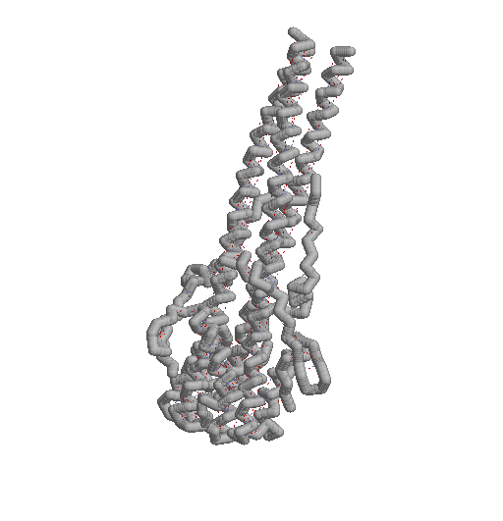
    - Hydrogen bonds are essential to the stability of secondary structures.
    - To add hydrogen bonds to secondary structures within your molecule:

      - RasMol>hbonds
        - After you have enter this command, you will notice that there are dotted lines that have appeared. These are the hydrogen bonds.
        - Since these bonds are very difficult to see, let’s give them an added dimension.

      - RasMol>hbonds 225
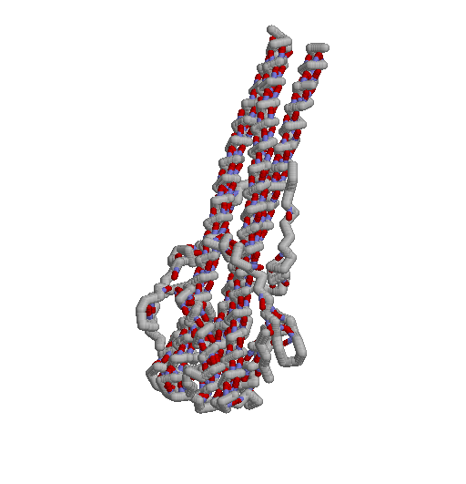
        - Notice that the Hydrogen bonds are now thicker, but that they appear to be floating in air. This appearance results from the fact that hydrogen bonds form between the atoms that make up the backbone of the amino acid (the nitrogen and the oxygen atoms), but since we have displayed only the alpha carbon atoms, it appears as if the hydrogen bonds are floating in space. Therefore, we must set the hydrogen bonds to the backbone. Notice that the bonds are blue/red, as they are based on the CPK color scheme since they connect an oxygen (red) to a nitrogen (blue).
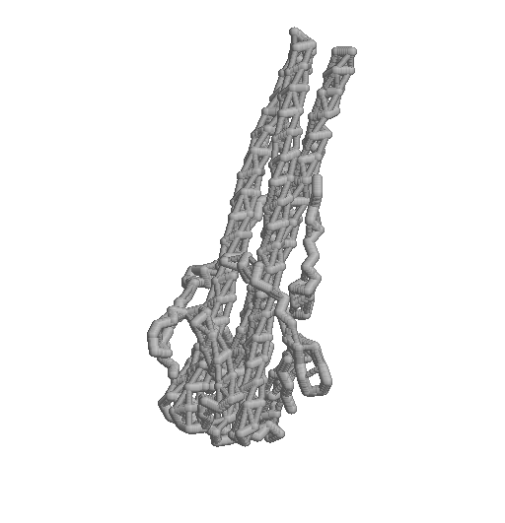
      - RasMol>set hbonds backbone
        - Notice that now the hydrogen bonds are attached to the alpha carbon backbone. The bonds are now colored gray since they are connecting the alpha carbon backbone, which is gray (carbon), to another part of the alpha carbon backbone. When bonds connect different sections, they adopt the coloring of the section that they are connecting.

      - To turn off the hydrogen bonds:
        - RasMol> hbonds off
          - This command will turn off expression of all of the hydrogen bonds within the molecule, bringing you back to the original state of the molecule in which no hydrogen bonds were displayed.

- Disulfide Bonds
  - Some molecules will have disulfide bonds present within the structure. These bonds are between two nearby cysteine amino acids. To visualize these bonds, we can type:
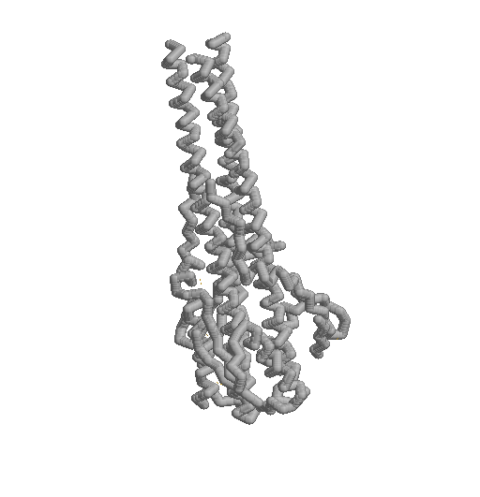
      - RasMol>ssbonds
        - As we saw with the hydrogen bonds, simply typing “ssbonds” will only produce dotted lines. To give these bonds dimension, we must add a value (thickness) to the ssbonds.

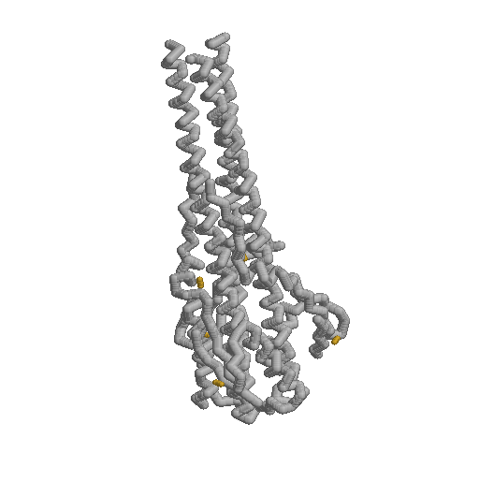
      - RasMol>ssbonds 225
        - Notice that this command gives the disulfide bonds a thicker dimension, but as we saw with the hydrogen bond, the bond is “floating” in space. This is because the disulfide bond is actually between the sulfur groups of the cysteine sidechains, and not the alpha carbons. To make the disulfide bond connect between the backbone units, we need to set the bonds to the backbone. Note that the disulfide bond is orange (the CPK color for sulfur).

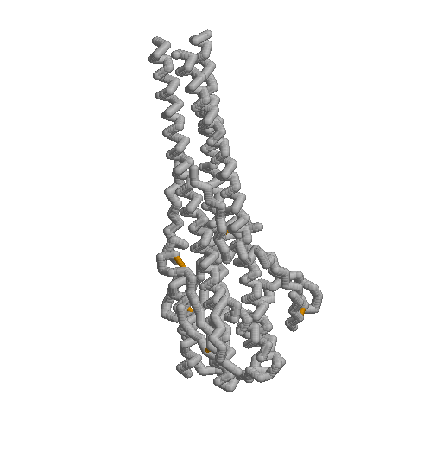
      - RasMol>set ssbond backbone
        - Notice that this command sets the disulfide bond to the backbone. Once it does this, the disulfide bond is now gray. RasMol will assign the bond to adopt the color of the backbone that the bonds connect. Since the backbone is gray, now the disulfide bond is gray. Since sulfur is orange in the CPK color scheme, we will enter a command into the command line window to color the bond orange.

      - RasMol>color ssbond orange
        - Note that we specified that we wanted to color the ssbond orange. We need to be specific that we want to color the ssbond orange. What happens if you type in “color orange”?

            - You may wish to display the disulfide bond connected to the cysteine sidechains, rather than to the backbone of the molecule.
              - In order to set the ssbond between the cysteine residues, you need to selectively display the cysteines.
              - After you have these amino acids displayed, you can the set the disulfide bond to the sidechains, rather than to the backbone.
                - RasMol>set ssbond sidechain
                - This will place the bond in between the sulfur atoms of the cysteines, rather than the alpha carbon backbone, as we saw earlier.
            - To remove ssbonds:
              - RasMol>ssbonds off

13. Identifying the Amino and Carboxy Termini
- An important concept in protein structure is that each protein has an amino terminus and a carboxy terminus. Through RasMol, each student can readily identify each of these termini.
  - Amino Terminus
    - The Amino Terminus is the first amino acid in the protein. When a protein is synthesized, it begins with the 5’ end of the mRNA and synthesizes in a 5’ to 3’ fashion. Therefore, the first amino acid in the protein will be the amino acid that is encoded at the 5’ end of the mRNA.
    - To determine the amino terminus of the protein in the PDB file, click on the atom at the end of the protein. The atom with lowest amino acid number will be the amino terminus.
    - Alternatively, you may search the PDB sequence information to identify the amino terminus amino acid and use the RasMol command line window to select the specific amino acid. (See Number 1, Sequence Details of the Protein Data Bank File).
  - Carboxy Terminus
    - The Carboxy Terminus, on the other hand, will be the last amino acid in the protein.
    - To determine the identity of the carboxy terminus, click on the atom at the end of the protein. The amino acid with the largest number will be the last amino acid in the protein
      - For example, in the 1HTM.pdb protein, in chain, the amino terminus is Ser 40 and the Carboxy terminus is Arg 153.

Conclusions for Section II

At the end of Section II, you should be comfortable with
- Searching the Protein Data Bank
- Reading a structure summary page
- Downloading a PDB File
- Saving script files
- Opening script files
- Editing script files
- The “wild card” (*) command
- Restricting a section of the molecule
- Centering the molecule
- Adding hydrogen bonds
- Removing hydrogen bonds
- Adding disulfide bonds
- Removing disulfide bonds
- Identifying the amino and carboy termini
Answers to Questions Posed within Section II

4. Searching the PDB and Reading a Structure Summary Page (practice)
- Use this structure summary page to answer the following questions about the PDB file (answers are at the end of this section):
  - Who are the authors of the PDB file?
    - Li F, Li W, Farzan M, Harrison SC
  - In which journal was the primary citation published?
    - Science
  - On what date was the file deposited into the PDB?
    - 1 August 2005
  - How many chains are in this file?
    - 4 (A, B, E, F)
  - Are there any heterologous groups within this PDB file? If so, which ones?
    - Yes
      - Zinc, Chloride, Mannose, N-acety-D-glucosamine
  - From what source was this molecule isolated?
    - Human

7. A little review from the previous section
- How do we do the following items?
    - (answers at the end of this section)
  - Change Background to white
    - RasMol>background white
  - Change display formats
    - Use the pull-down menu (display)
    - Use command line window
      - RasMol>backbone
      - RasMol>wireframe
      - RasMol>spacefill
  - Change colors
    - Use the pull-down menu (color)
    - Use the command line window
      - RasMol> color red
  - Highlight the helices as red
    - RasMol>select helices
    - RasMol>color red

Question: Why are there so many hydrophobic amino acids located on the outside of this protein when we learn that hydrophobic amino acids are typically located buried within the molecule, away from the aqueous external environment?

Answer: The K channel is a membrane embedded protein and therefore will be in contact with a hydrophobic region of the membrane. As such, it is necessary for the part of the K channel that interacts with the hydrophobic portion of the membrane needs to be hydrophobic as well.

