RasMol Training Section I:

Using RasMol as a Computer Visualization Tool

Section I of the MSOE Center for BioMolecular Modeling RasMol Training Guide is designed to assist you as you begin your exploration of RasMol. This program is a simple, yet powerful tool, which enables you to visualize a molecule in “3-Dimensional space”. Since you actively manipulate the computer mouse to rotate the molecule in computer space, you develop a sense of the 3-dimensionality of the molecule. Through RasMol, you can also change the display format of the molecule to display different features of the molecule.

One of the goals of the CBM is to combine the use of the physical models with the computer visualization tools in order to allow you the opportunity to further explore the relationship between the structure of a biomolecule and its function. Often times, you will manipulate a CBM-produced model and through your interaction with the model, will generate questions that can be answered by working with RasMol. Through this tutorial, you can become familiar with this program to enable them to further explore the structure/function relationship that is a focal point in biochemistry.

At the end of this section, you should be familiar with how to use RasMol as a computer visualization tool. We will introduce you to the basic features of RasMol, including how to:
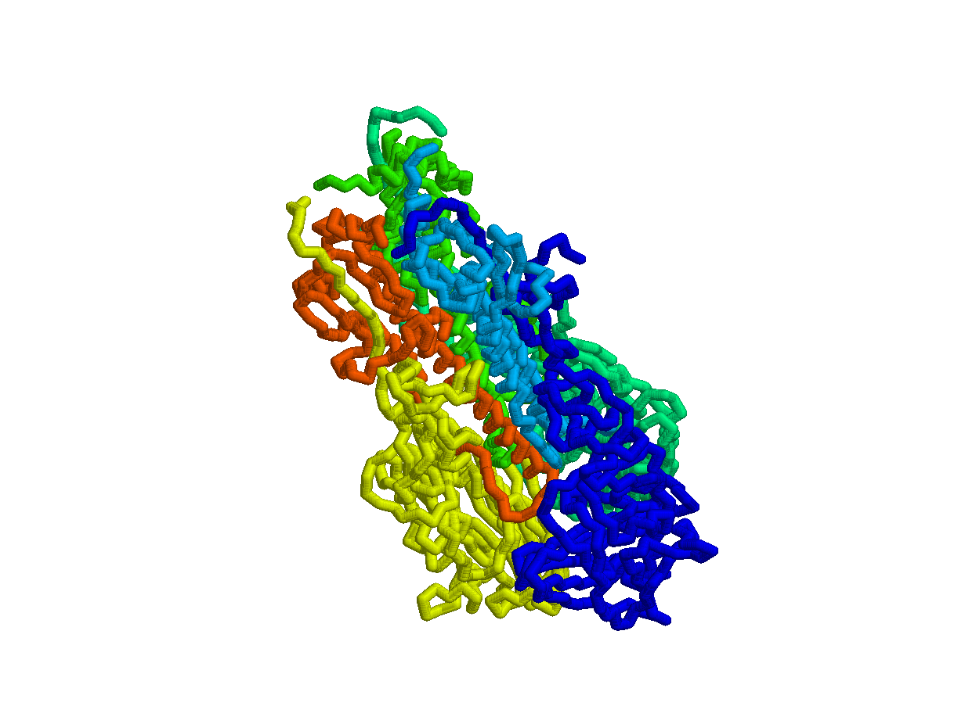
  - Organize your files
  - Start RasMol
  - Open a PDB File
  - Change the Background Color
  - Change Display Format of the Molecule
  - Use the Command Line to Change Formats
  - Change Colors
  - Identify Features within the Molecule
  - Select Features within the Molecule

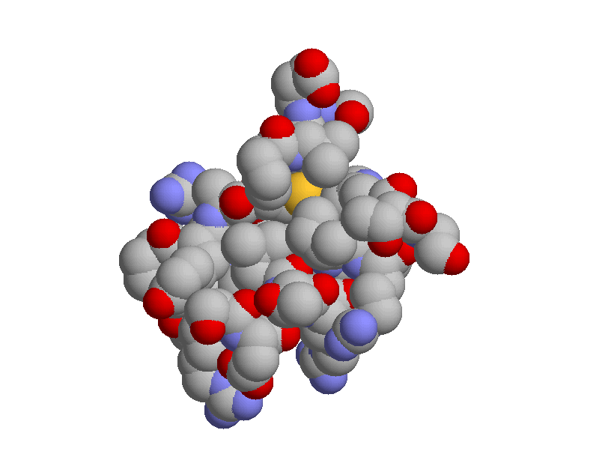
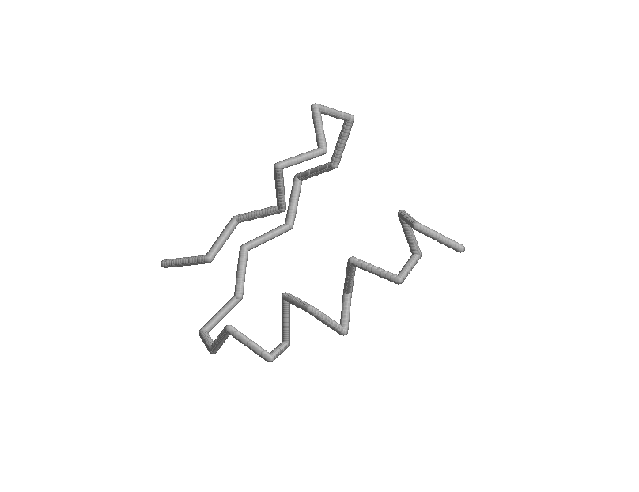

1. Organize Your Files
- We recommend that you maintain separate folders on your computer (desktop or preferred disk drive location) for separate projects.
  - For instance, if you are using RasMol for SMART Teams, you should have a separate folder for each of these projects. Within these “larger folders”, keep a separate folder for themes, subjects or projects. This will enable you to keep subjects separated and will become important if you do any design work or generate script files, a way to save your work within RasMol (see RasMol Training Part II).
- In each folder, place a copy of RasMol and the PDB file with which you are working.
  - As you become more familiar with the program and begin to develop script files, you will probably have several folders with PDB files and script files. RasMol is a small program and it is okay to make multiple copies of it within your computer. We recommend that for each new project that has a new PDB file, you place a copy of RasMol in that folder. This will become especially important as you use RasMol to explore more molecular structures.
  - You can download a copy of RasMol from the CBM website: http://www.rpc.msoe.edu/cbm/smartteams/resources.php

2. Opening RasMol
- To open the RasMol program, double click on the RasMol icon in your folder:

- RasMol has Two Screens
  - You will notice that when you open the RasMol program, a window automatically opens with a black background on your computer monitor. In addition, there will be two buttons that appear on the Task Bar (see figure below). This is because there are two windows associated with RasMol: a Command Window and a Visualization Window.

Note: These directions are specific for PC-users. Macintosh users will utilize RasMac, will have the essential components described herein, but may also have differences. Please see the appendix for Macintosh-specific directions.
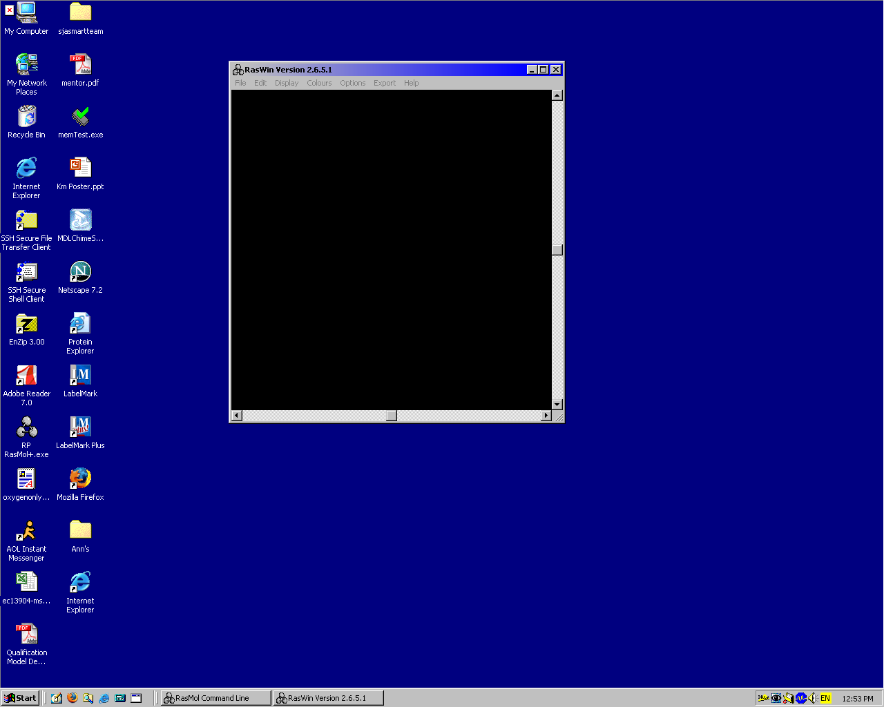
Molecule Visualization Window

When you launch RasMol, this is an image of what will appear on your monitor. Notice the two buttons on the task bar. One button will open the command window (the one on the left) and the other button will open the visualization window (the button on the right; this window will open automatically upon launching of RasMol). Open both of these windows and arrange them on the monitor so that you can see both of them on the screen.

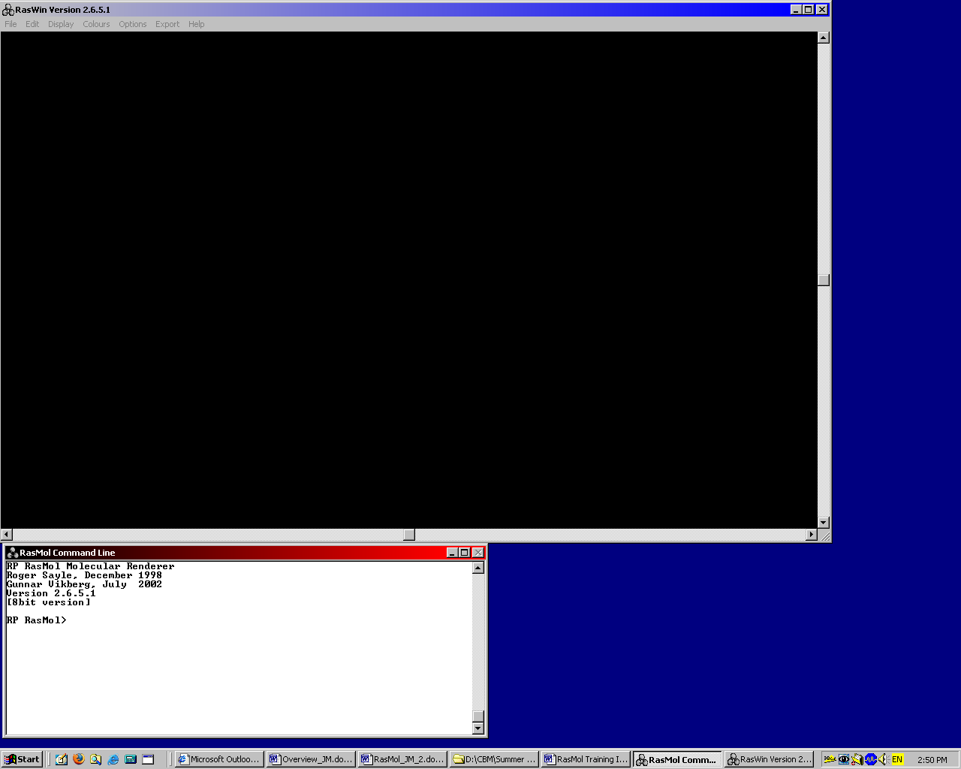
In order to work most effectively with RasMol, we recommend that you organize your screen to display BOTH of these windows. To open the Command Line Window, click on the RasMol Command Line button on the task bar. Arrange the Molecule Visualization window and the Command Line window so that you can see both windows and they are not overlapping. You can resize the windows to accommodate your preferences or computer monitor size. You will want the Computer Visualization window to be larger.

3. PDB Files
- RasMol is a molecular visualization program that enables us to visualize the atomic coordinates of a molecule that has been crystallized.
- These coordinates are stored in a file called a PDB (protein data bank) file.
- PDB files can be located and downloaded for free from the Protein Data Bank website (www.pdb.org).
- More information about saving a PDB file and understanding the information contained within the file will be discussed within RasMol Training Part II.
- For initial exploration of RasMol within Section I of the RasMol Training Guide, example PDB files that are used within this tutorial can also be found on our website at:
  - http://www.rpc.msoe.edu/cbm/smartteams/resources.php

4. Opening a pdb file
- After both windows of RasMol are opened and arranged on the screen, use the Pull-Down menu bar located on the Molecule Visualization window and chose “File.”
- Click on “Open” in order to open a PDB file
  - This will bring up a window entitled “Select Molecular Coordinate File” that will allow you to direct the program to open a specific pdb file.
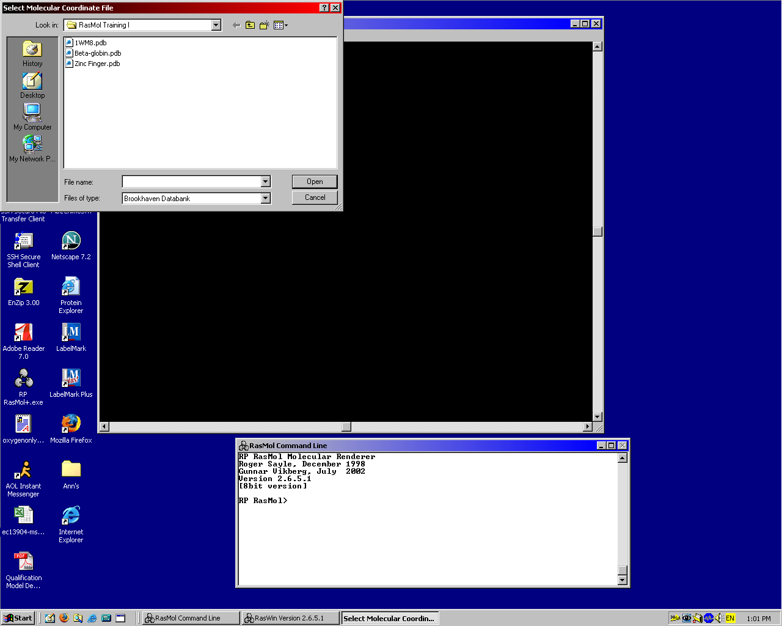
  - Click on the appropriate pdb file that you wish to open.

  - NOTE: Organizing your design work will be simplified if you always do the following: Create a RasMol folder with the RasMol program and the PDB file, open the RasMol program by clicking on the RasMol icon inside the folder, use the pull down menu to open the PDB file with the commands >File>Open.

5. Default Display of Molecule
After you open the PDB file, the molecule will appear in wireframe format in the Molecule Visualization window. The wireframe format is the default setting and every time that you open a file, this is the initial format you will see. In the wireframe format, the thin wire represents the bonds between each of the atoms. We will change the format in a moment.

6. Commands within RasMol
- There are two ways to enter commands and change the display of the molecule in the RasMol program:
  - One way is to use the Pull-down menu and select specific commands (like we just did with opening the PDB file).
  - The other way is to type specific commands into the Command Line window.
    - In the Command Line Window, you will see the prompt “RasMol>”. By typing commands at this prompt, RasMol is directed to do certain things. The commands that are entered at this prompt need to be specific. We will discuss this specificity in more detail as we progress through the training guide.
  - For the remainder of this section in the training guide, a combination of commands (both in the command window and the pull-down menu) will be used.

7. Closing a PDB file
- If you have completed work on one PDB file and would like to work on another file, you need to close the PDB file that you are presently working on before you can open a new PDB file. RasMol will not open another PDB file over the original. You must close the current file to open the next one.
- There are two ways to close a PDB file: using the Pull-down menu or using the Command Line window
  - Using the Pull-Down Menu
    - To close a PDB file, use the Pull-Down menu bar located on the Molecule Visualization window and chose “File.”
    - Click on “Close” to close the PDB file.
  - Using the Command Line window
    - To close a PDB file, type “zap” at the prompt.
      - RasMol>zap

8. Background Color of Molecule Visualization Window
The default setting for the Molecule Visualization window will be a black background. This can be modified and you can select any color for the background. Dark colors are not recommended if you wish to print an image of your molecule.
- To change the color of the background:
  - RasMol> background white
    - This will change the background of the window to white.
  - RasMol> background green
    - This will change the background to green.
      - This is obviously not a very nice color at which to look for most people, but for some reason, some people like this color.
  - RasMol> background blue
    - This will change the background to blue.
    - You get the idea. You can change the color of the screen to any color that you wish. We recommend white, as this has been the color that has worked the best for the most people. It also serves as the best backdrop if you export a picture (*.gif) so that you do not have a black (or green) background for your model. This saves on ink when printing, especially for posters. (See Number 14 in this section of the training guide for how to export an image of your molecule.)
    - Note: We recommend that you avoid the red/green color combination in case you, or others, have problems with color blindness.

9. Rotating the Molecule
- To rotate the molecule within the X-Y axes on the computer screen, place the mouse cursor in the Molecule Visualization window, hold down the left mouse button. Moving the mouse will rotate the molecule about the X-Y axes
- To relocate the molecule within the Molecule Visualization window, (for instance, to center the molecule within the window), place the mouse cursor in the Molecule Visualization window, hold down the right mouse button and move the molecule to the desired location.
- To zoom in or out, place the mouse cursor in the Molecule Visualization window, hold down the left mouse button AND hold the shift key. Moving the mouse will then zoom in or out on the molecule.
  - A word of caution: if you zoom in or out too fast, RasMol may close (crash) unexpectedly, as the program has to re-render the image at each step. Zooming too quickly, especially with large molecules, will overwhelm RasMol and the program will crash.
- To rotate the molecule within the Z axis, place the mouse cursor in the Molecule Visualization window, hold down the right mouse button and the shift key. Moving the mouse will then rotate the molecule about the Z axis.

Table Summarizing Mouse Button/Key Needed for Actions within RasMol

Action | Mouse Button (and Key) Needed
Rotate X-Y | Left Mouse Button
Move Molecule | Right Mouse Button
Zoom In/Out | Left Mouse Button & Shift Key
Rotate Z | Right Mouse Button & Shift Key

10. To Change the Format of the Molecule
- There are two ways to change the format of the molecule. One is through the pull-down menu and one is through the command line. We will do both so that you are familiar with both aspects. As you become more comfortable with the program, we do recommend that you use the command line rather than the pull-down menu.
  - Using the command line allows you to add or subtract specific features one at a time. If you have created a design using the command line and then use the pull-down menu, the pull-down menu will overwrite all of the molecule features that you have created. This is more important as you develop more sophisticated models with specific features highlighted. In Section III of this RasMol Guide, we will do some exercises that will illustrate this point.

11. Changing format with the Pull-Down Menus
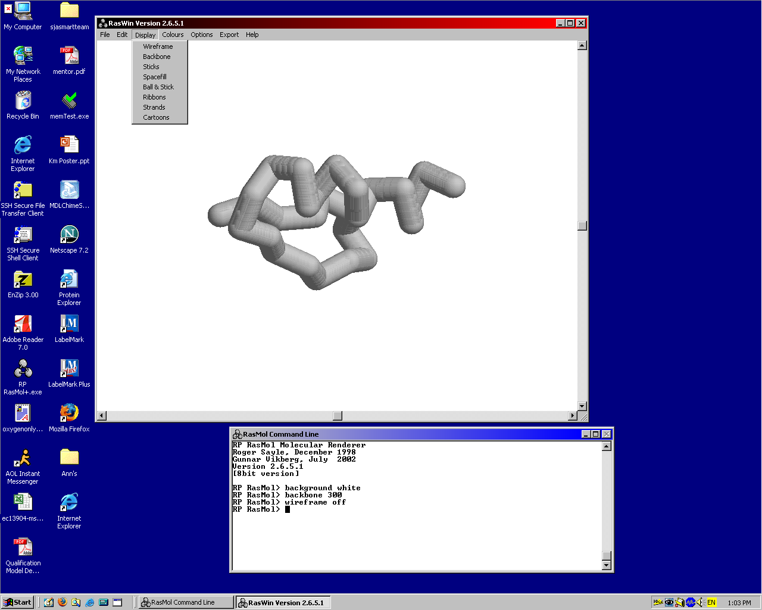
- Under the Pull-down menus in the Molecule Visualization Window, there is a “Display” option (see figure below). Within this pull-down menu, there are several different formats that you can choose to display your model:
  - Wireframe
  - Backbone
  - Sticks
  - Spacefill
  - Ball and Stick
  - Ribbons
  - Strands
  - Cartoon

- Each of these display options will render your molecule in a different format. Some of these options will look new to you and some of them will look very familiar. When we start talking about designing a model for building purposes, we will talk more about which options are available for building, but for now, we are simply talking about using computer visualization programs and therefore we will cover each of the formats.
  - Each option has its advantages and disadvantages; which option you choose to display your molecule depends on which story you wish to tell. The advantage of using RasMol within the classroom is that it enables you to represent the model in a variety of ways, thus illustrating different aspects of the molecule.

- Let’s look at each of these in turn and see what the different formats represent.
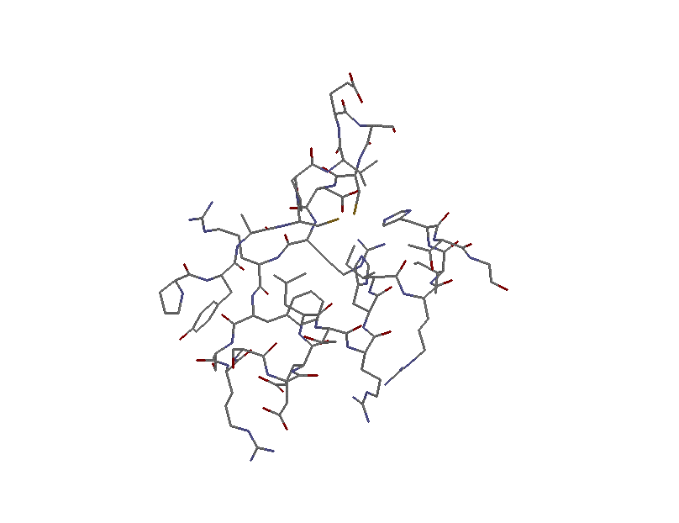
    - Please note that the images to the right are of a single zinc finger and are based on amino acids #4-31 of the PDB 1ZAA.pdb.

  - Wireframe
    - This is the RasMol default format for displaying molecules initially opened in RasMol. The thin wire represents the bonds between each of the atoms and the ends of the wires represent the atoms. The advantage of the wireframe is that all of the atoms are displayed. It is difficult to distinguish secondary structures in this format.

  - Backbone
    - The alpha carbon backbone format only displays the position of the alpha carbon in each amino acid by a bend in the backbone. All of the other atoms within the amino acid are not displayed. The advantage of this display format is that it clearly illustrates the secondary structures within a molecule.

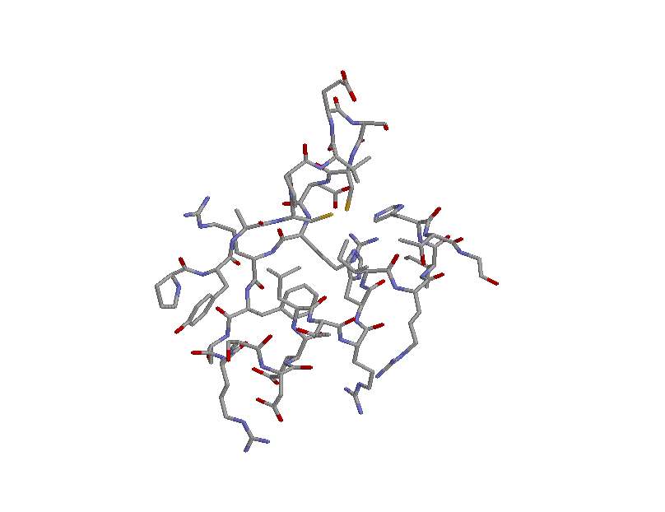

  - Sticks
    - This display format is similar to the wireframe format, but rather than a thin wire, the atoms are connected by a stick. As in the wireframe format, all of the atoms in the molecule are displayed.

  - Spacefill
    - In this format, each atom is displayed as a sphere representing the volume that atom occupies in space. For example, hydrogen atoms are smaller than carbon atoms, which are smaller than sulfur atoms. This format is advantageous in that the spacefill model represents the volume and three-dimensional shape of a molecule. Identifying the secondary structures or any internal atoms in this display format is challenging.

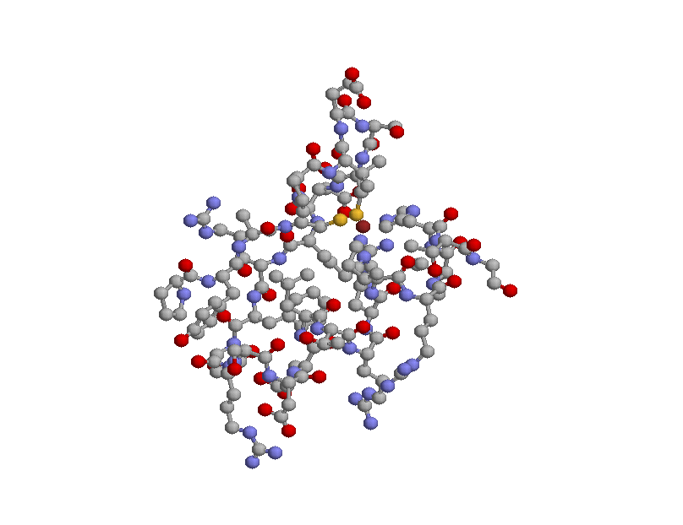
  - Ball and Stick
    - In this format, each atom is represented by a small sphere (ball) and the bonds connecting each atom are indicated by a stick connecting the spheres. If the molecule is very large, this representation can become too overwhelming and specific information about the molecule can be difficult to determine.

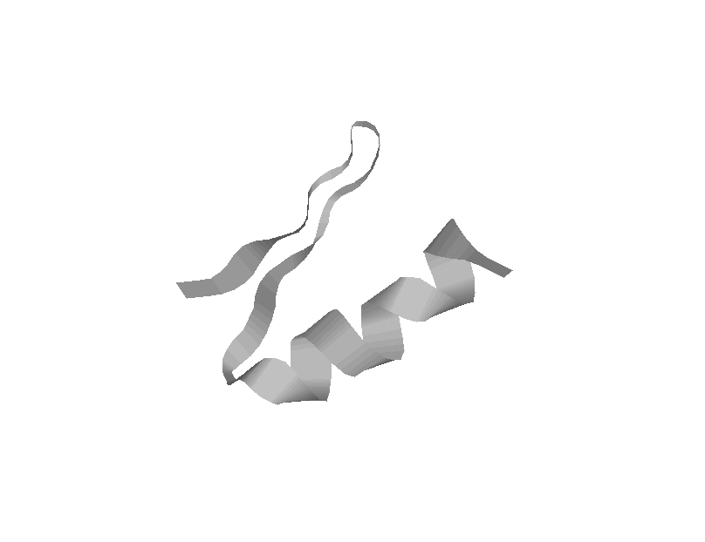
  - Ribbons
    - This format shows the molecule as if it were traced with a ribbon. This version may be familiar as it is often seen in textbooks. Secondary structures are easily identified within this format with the alpha helix represented as a coiled structure and the beta strand represented as a pleated structure.

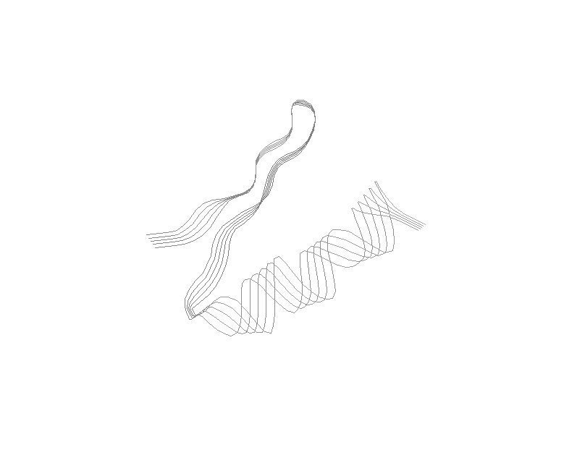

  - Strands
    - This format is similar to Ribbons, except that rather than being a solid ribbon, there are several “strands” or thin lines that make up the model.

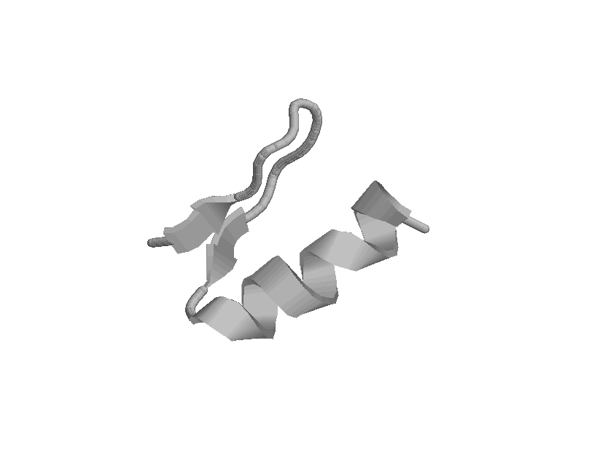
  - Cartoon
    - This format is similar to Ribbons, except that the beta strands are indicated by arrows to point out the directionality of the strands. This version is also widely seen in textbooks.

Format | Advantage | Disadvantage
Wireframe; Sticks; Ball and Stick | Displays all atoms | Difficult to distinguish secondary structures; too busy for large structures
Backbone | Secondary structures clearly seen | Detail of amino acids is lost, unless specifically added
Spacefill | Represents 3D volume and shape | Cannot identify secondary structure or internal atoms
Ribbons; Strands; Cartoon | Secondary structures are easily visualized; cartoon shows directionality of beta strands | No structural details

12. Changing display format with the Command Line
- In the command window, you can change the format of the model by typing the following commands:
  - RasMol>Backbone
  - RasMol>Wireframe
  - RasMol>Spacefill

- To generate the Ball and Stick image, you would use a combination of the wireframe and spacefill commands.

- In contrast with the Pull-down menu in the Molecule Visualization window, in the Command Line window, you can also alter the size. When we get to the model design stage of this training (in section III), this will become especially important. For now, we will just vary the sizes so that you can see what we mean by changing the size of the different formats. Following the format command, you enter a value for the size. Each format as a range of values, usually between 1 and 750. For scaling purposes, 1 RasMol unit equals 1/250 Angstroms.

- Enter the following commands in the Command Line window to see the effects of the commands:
  - RasMol>backbone 300
  - RasMol>backbone 30
  - RasMol>spacefill
  - RasMol>spacefill 100
  - RasMol>wireframe 200
  - RasMol>spacefill 300

- If you want to turn off a particular format, you would enter the following command
  - RasMol>spacefill off
  - RasMol>wireframe off

13. Changing color with Pull Down Menu
- RasMol has several color display options to make your model look visually pleasing, or to indicate specific features of the molecule.
    - Figures to the right are of hemagglutinin, a protein found on the flu virus membrane and are based on 2HMG.pdb.

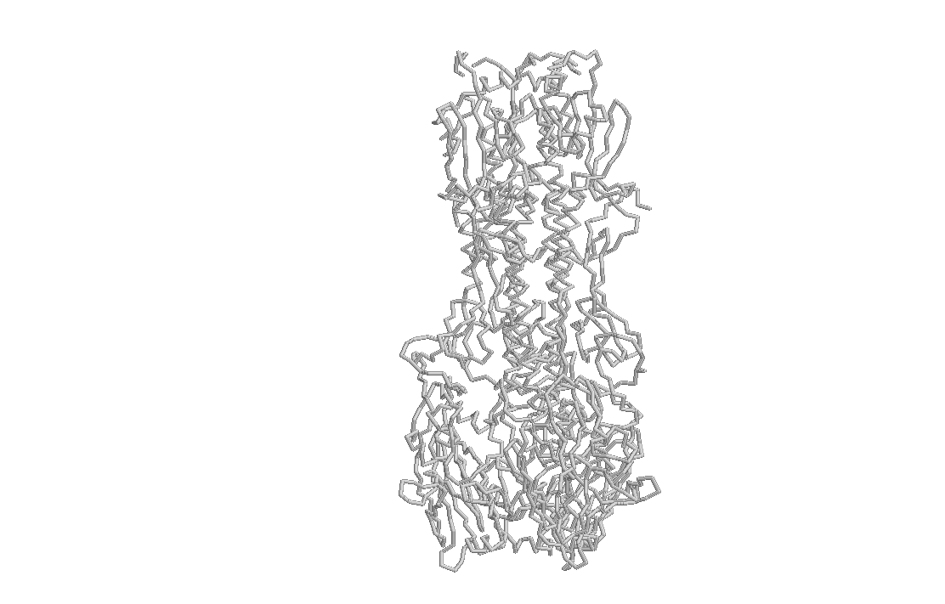
The most frequently used color options are:
  - Monochrome
    - This option will color the entire molecule white. This is often a good starting point if you would like the model to have a white backbone with other colors highlighting different features (to be discussed in number 16).

  - CPK
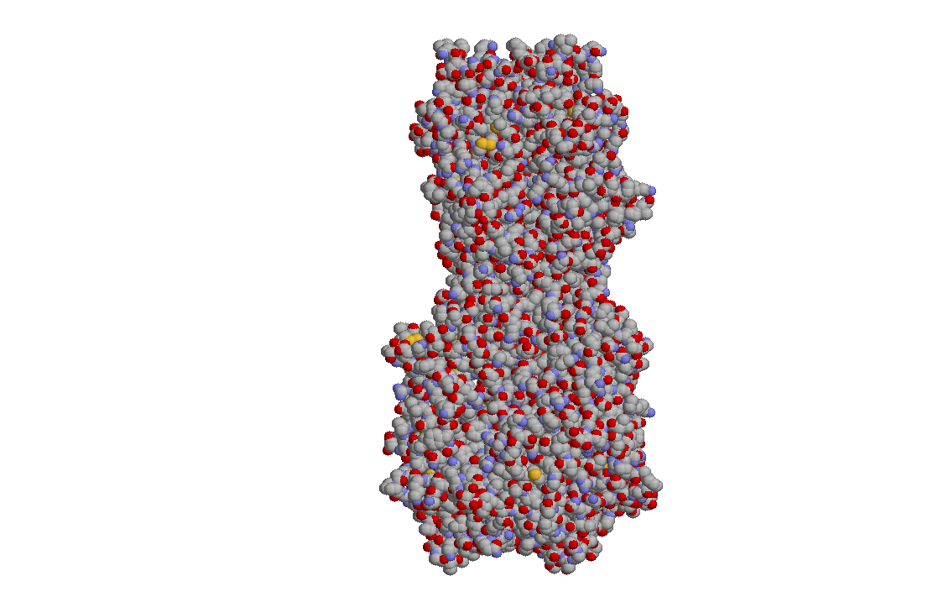
    - This color scheme was developed by Corey and Pauling and later improved by Kultin in which carbon is gray, hydrogen is white, oxygen is red, nitrogen is blue. This is the standard color code and is utilized in many textbooks.

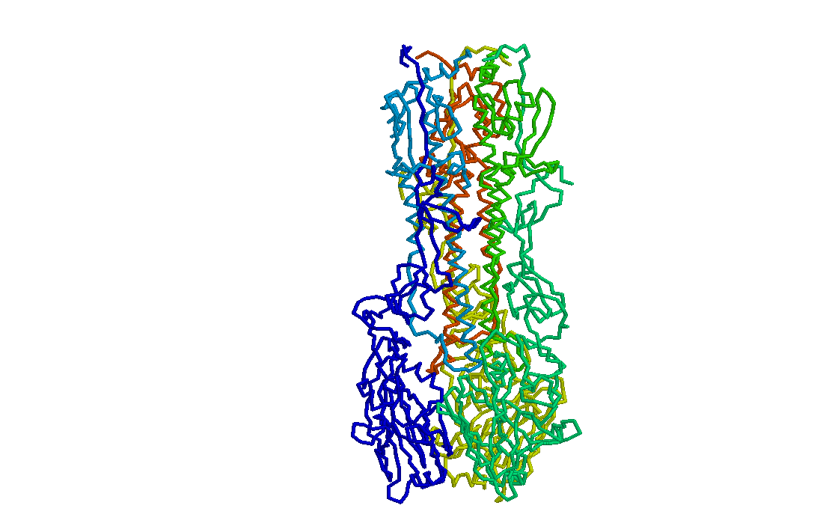
  - Chain
    - If a PDB file has multiple polypeptides, as seen in the hemagglutinin protein on the right, in which there are 6 chains, or in the protein hemoglobin, in which there are 4 chains, this color option will color each chain a different color.

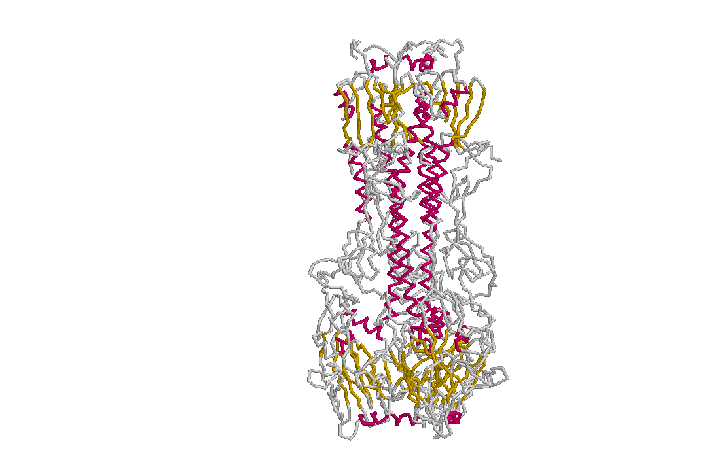
  - Structure
    - This option will color the secondary structures different colors. Magenta is used to highlight helices, yellow to indicate beta sheets and blue to indicate turns (this feature is not shown in this figure).

14. Exporting an Image from RasMol
      - If you would like to create a *.gif image from RasMol, you can do so using the pull-down menu option “Export”

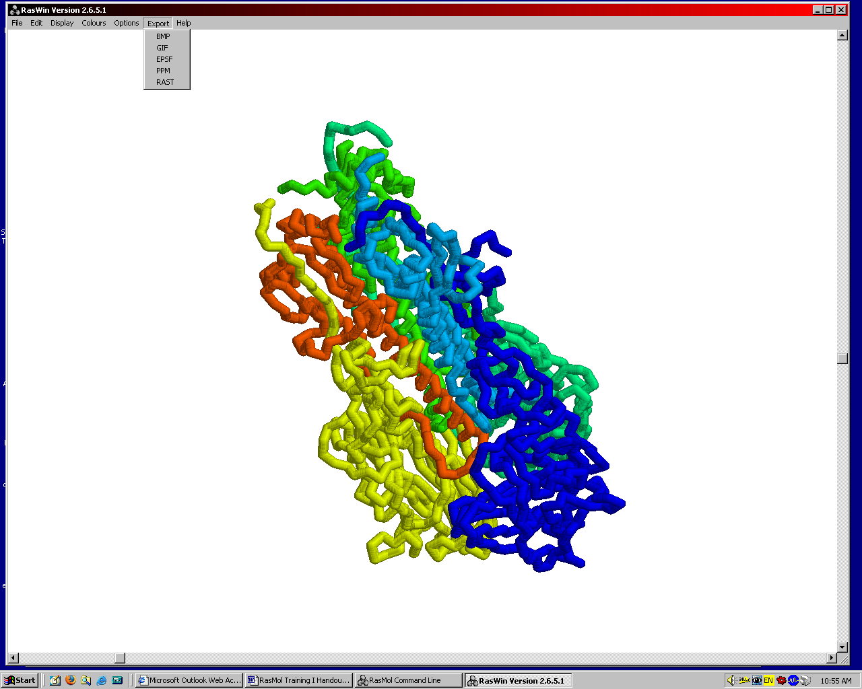

      - This menu option will then provide you with several different graphic formats (.gif, .bmp, etc) from which you could choose to save your image. After you select which format you would like to export your image, a save window will appear and you will be asked to name your file and direct the computer to which folder you would like to save the image.
      - The exported image that is saved will look exactly like the one that is on your screen, which means that if you have a blue background, your image will also have a blue background. This is the reason why we recommend that you change the background to white if you plan to export any images.

15. Identification Feature of RasMol
- One of the features in RasMol is an identification feature that enables you to determine the identity of an atom by placing the mouse cursor over the molecule and pressing the left mouse button. After you click the mouse button, a line will appear in the command window giving identity information about the point on which you clicked.
- The format of the information displayed in the Command Line window will be similar to the following:
        - Atom: CA 140 Group: Asn 19 Chain: B
          - This line gives you several pieces of information:
            - The atom is the alpha carbon (CA) and it is assigned atom number 140.
            - This alpha carbon belongs in the Asparagine amino acid, which is the 19th amino acid in this PDB file [Note: the amino acid number in a PDB file does not always correspond with the amino acid in the protein.]
            - The atom is in chain B of the molecule.
          - This information will be useful in several ways, which we will discuss later in our training.

16. “Select” command
- You can specifically select certain features within your molecule when using RasMol.
- There is a set of predefined terms that are recognized by RasMol (see Quick Reference Guide for full listing) http://www.rpc.msoe.edu/cbm/resources/pdf/refcard.pdf
- Once you select a portion of the molecule, all subsequent commands will apply to that selected portion. RasMol will not know that you meant to select another subset, or that you were done with that set of features, and so you must be very specific with your commands.
  - Examples:
  - Secondary Structures
    - RasMol>select helices
      - This command will select all of the helices within the molecule.
      - After you have selected the helices, you can enter a command to change the format or color, and this command will ONLY be applied to the helices.
        - For Example: RasMol>select helices
RasMol>color red
This series of commands will color the helices red.
      - NOTE: At this point, you have selected the helices. If you enter any other commands, such as a new color, or display format, all commands will be applicable to JUST the helices. You will need to select a new subset of features, or “select all” to get out of the helix-selected mode.

    - RasMol>select sheets
      - This command will select all of the beta sheets within the molecule.
      - As we did with the helices, you can color the sheets any color, or change the format in which you have the beta sheets displayed.

  - Heterologous Groups
    - RasMol> select hetero
      - This command will select all of the hetero atoms that are contained within this file. Remember that these are the atoms that are NOT amino acids. Examples include heme groups, zinc atoms, ADP and water.
      - If you know the name of the group, you can select it directly by its name (such as “Select Zn”)

  - Amino Acid Sidechains
    - Within any molecule, you may wish to display all of the amino acids, or a specific set of amino acids (such as all of the hydrophobic amino acids), or only a select few amino acids based on function (such as the amino acids that make up an active site of an enzyme). Through entering commands in the Command Line window, you can make these selections.

RasMol Exercise
    - Let’s practice selecting amino acids:
      - Open a PDB file in RasMol
        - Example PDB files can be found
http://www.rpc.msoe.edu/cbm/smartteams/resources.php

      - Change the background color to white
      - Change the display format to backbone

      - To select all of the amino acids:
        - RasMol>select sidechain
        - RasMol>spacefill 275
        - RasMol>wireframe 225

      - To select a subset of amino acids, you can use predefined terms, such as “polar” or “hydrophobic” to display all of the amino acids that are in these categories.
          - Note: There is a list of predefined terms that RasMol recognizes on the RasMol Quick Reference Guide.

        - To select all of the polar amino acids:
          - RasMol>select polar
          - RasMol>color red

        - To select all of the hydrophobic amino acids:
          - RasMol>select hydrophobic
          - RasMol>color yellow

        - You can also select all of particular amino acid, such as all of the histidines in a molecule.
            - Note: RasMol recognizes the three letter abbreviations for the amino acids.
          - RasMol>select his
          - RasMol>color magenta
            - This allows you to identify all of the histidines within the molecule. By moving the mouse cursor over these magenta regions, you can click on them to identify which histidine the amino acid is in order to determine the amino acid number so that you can select this amino acid specifically.
        - To select functionally significant amino acids, you could refer to the primary citation associated with the PDB file (more on that in Part Two of the training). If you know that you want to display the sidechains for a particular amino acid, for example Histidine 63 in the beta-globin protein, you would select that amino acid specifically.
          - RasMol> select His63
            - Note: Although we typically write His 63 with a space between the letters and the number, there is not a space between the letters and number when writing a command in RasMol.
          - RasMol>spacefill 275
          - RasMol>wireframe 225
            - These commands will generate a ball and stick representation of all of the atoms in the amino acid. Please note that ALL of the atoms within the amino acid are displayed as balls and not just as the sidechain atoms. This is a “bumpy backbone” versus a “clean backbone” and we will discuss this difference in Section III of the RasMol Training Guide.

          - RasMol>color CPK
            - This command will color the sidechains CPK.

17. Changing color with Command Line
- To change the color of the model with the command line, there are two options: to use the predefined color list (refer to Quick Reference Guide) or to use the RGB color numbers (again, use the Quick Reference Guide, or any source that indicates RGB [computer color system of Red, Green, Blue] color numbers).
  - RasMol> select helices
  - RasMol> color red OR RasMol> color [240,0,0]

Conclusions for Section I

Hopefully at the end of this section, you feel comfortable:
- starting RasMol on your computer
- opening a PDB file
- changing the background color
- changing the display format of the molecule
- changing the colors of the molecule
- selecting certain features of the molecule
- using the pull-down menu
- using the command line

Through these features, we encourage you to use RasMol within the classroom as a visualization tool to enhance your lessons on biochemistry.

Additional Exercise

Exercise I
- Start RasMol and open Zinc Finger.pdb in RasMol. (can download this file at http://www.rpc.msoe.edu/cbm/smartteams/resources.php)
- Change the background color to white.
- Display zinc finger in the alpha carbon backbone format.
- Display Zinc ion in relation to the zinc finger
- Display sidechains for the histidine and cysteines coordinating the zinc ion
- Display the sidechain for Phe16
- Display the sidechain for Leu22
- Display the sidechain for Arg18

Exercise I Answers
- Start RasMol and open Zinc Finger.pdb in RasMol.
- Change the background color to white.
RasMol>background white
- Display zinc finger in the alpha carbon backbone format.
RasMol>backbone 300
RasMol>wireframe off
- Display Zinc ion in relation to the zinc finger
RasMol>select zn
RasMol>spacefill
- Display sidechains for the histidine and cysteines coordinating the zinc ion
RasMol>select his
RasMol>spacefill 275
RasMol>wireframe 225
RasMol>select cys
RasMol>spacefill 275
RasMol>wireframe 225
- Display the sidechain for Phe16
RasMol>select phe16
RasMol>spacefill 275
RasMol>wireframe 225
- Display the sidechain for Leu22
RasMol>select leu22
RasMol>spacefill 275
RasMol>wireframe 225
- Display the sidechain for Arg18
RasMol>select arg18
RasMol>spacefill 275
RasMol>wireframe 225

