Tropical Research and Education Center (TREC)
San Pedro Ambergris Caye, Belize
June , 2010 (week after exams)

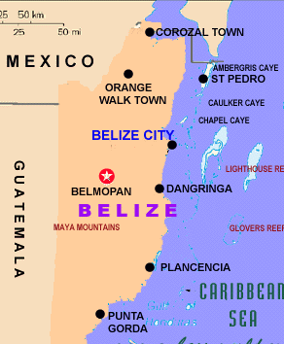
What is TREC?
This is an organization dedicated to research, education, and conservation. It is a school environment that provides visiting students with all components necessary for conducting a course. The center is starting its 14th year of coral reef education and research. It is a large compound that can accommodate over 50 students for room, board and course work. There is a Research Library, Natural History Museum, classrooms, laboratory, fresh water swimming pool, fleet of boats and a remote field station. The staff includes a Ph.D. in Marine Biology (Ken Mattes), Scuba Instructors, Registered nurse (Maureen Gannon), Licensed tour guides, and professional captains.
Why San Pedro, Ambergris Caye?
There are fewer tourists which automatically enhances the experience of the student. This area contains the second largest barrier reef in the world a half mile from the classroom at TREC. It also boasts the healthiest reef in Caribbean and is nearby to Mayan ruins and native culture.

There are many North Americans in residence and lots of Americans, Canadians and Europeans visiting as tourists. This island just south of Mexico’s Yucatan is about one-half the size of Barbados, with a population estimated at 10,000. The only town is San Pedro, which has three main streets, all sand.

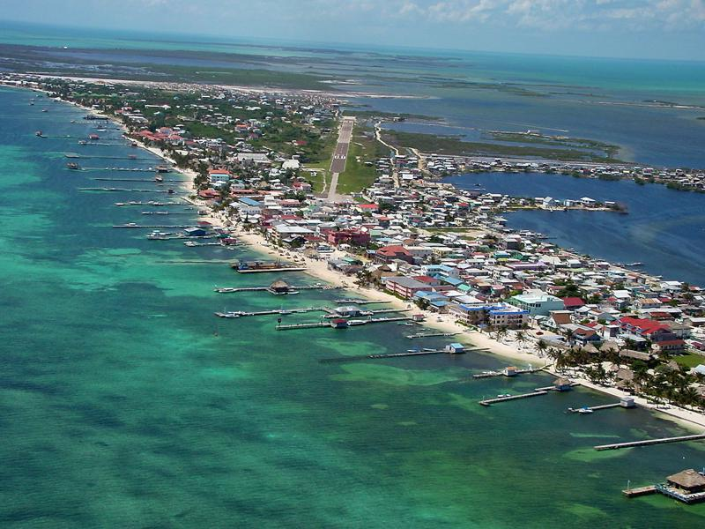

There are two Catholic churches and several Protestant churches, a small library, several good small groceries, a number of tourist-oriented shops and many good restaurants in all price categories. While some residents own cars, the most common form of transportation on the island is the golf cart.

Are we safe?
The people of the area are bilingual and English is the national language of Belize. San Pedro and Ambergris Caye have a relatively high standard of living with no begging and harassment. There is safety on the beaches and streets of San Pedro. The TREC facility is an enclosed compound with all facilities with within the gates of the campus. The gates are locked at night and kids are prevented from leaving the compound. Medically, there are four medical doctors in San Pedro and two medical clinics in addition to the registered nurse on the TREC staff.

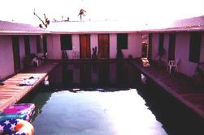

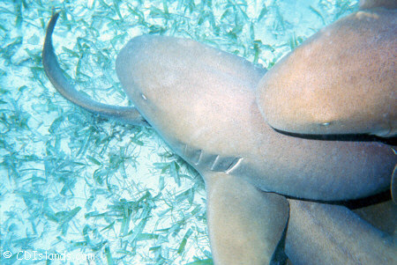
What will we be doing?
Academic programs may include lectures, species ID, Habitat analysis, census work, field and laboratory research methods, research projects, sampling techniques, monitoring and mapping of reef, data presentation. We are expecting students to prepare an extensive journal of the experience as well as some preview reading.
Tentative:
Morning Afternoon Evening
Day 1 Departure
Newark to Houston, Houston to Belize,
connecting flight to San Pedro- Mayan Island Air
Cab to TREC

Day 2 Snorkel Lagoon and Grass beds Beach walk Lecture Lab
Day 3 Snorkel Tuffy Lecture/Lab Night Beach Seine
Day 4 Day trip to Mayan Ruins
Day 5 Snorkel Tres Coco Lecture Lab Night Snorkel
Day 6 Day trip to Snorkel Hol Chan, Picnic Lunch, Snorkel Coral Gardens Farewell Dinner
Day 7 Departure Connecting flight to Belize City Mayan Island Air Belize to Newark

Labs are conducted by a visiting adjunct professor to TREC and are on a variety of marine biology topics ranging from conservation biology to structural biology.

What is the weather like?
Ambergris Caye enjoys the sun and heat of the tropics, but is cooled by the trade winds off the Caribbean Sea. Temperatures range from 75 - 95 degrees in the day, year round. The rainy season is May to February, with most of that falling in late afternoon and evening. While southern Belize may get up to 140 inches of rain per year, Ambergris Caye only receives about 40 inches per year. The water temperature is always around 82 degrees.

What should I pack?
Limit 1 50 lb. suitcase per person and 1 small carry-on (strictly enforced)
Dress is casual- Bathing suits (several are suggested), short, t-shirts, a fleecy sweatshirt for cool evenings. Quick drying rash guards are helpful for long days on the water but we will be in and out of the water constantly so bring items that will dry quickly. Sunscreen is a must as well as lip protection. They suggest hat and sunglasses and towels. Overall, keep “outfits” at home, pack lightly and pack to be at the beach and in the water. We will visit San Pedro town but again casual dress is appropriate. It would be appreciated if t-shirts with inappropriate saying, pictures, etc. are left at home. Meals except during travel time are included but spending money in smaller denominations is recommended.

What if there is an emergency and we need to contact you?
Cell phones have worked nicely in Belize when trying to reach the continental US but we will have direct phone number to the dining hall of TREC so that you can reach us easily.

