Writing Electronic Configurations for the Elements
(adapted from D. Maxwell 2008)

Electrons are divided into Energy Levels
Each energy level has a defined amount of energy (which determines the electrons’ energy too.) Each energy level can be divided into orbitals. There can be many orbitals per energy level.

1st energy level has 1 orbital which can hold two electrons
2nd e.l. has 4 orbital levels, each hold two electrons
3rd e.l. has 9 orbitals, each holds two electrons

Remember that orbitals are spatially defined probabilities of finding an electron. These are areas of high probability of finding an electron have been determined mathematically. AND- we are talking waves….
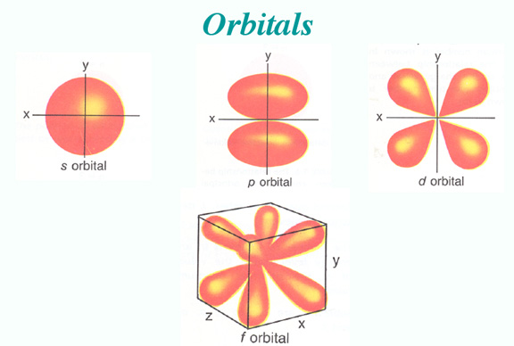

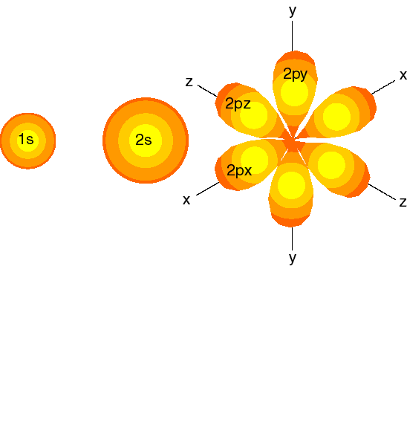

Knowing how an atom's electrons are arranged around the nucleus can help us predict the chemical properties of the atom. The periodic table can be used to determine how each different atom holds its electrons. Usually, we see the periodic table organized as shown below. 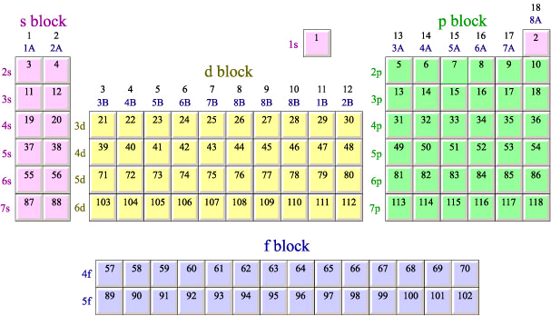

It is important to remember that the inner-transition elements (f block) fit between columns 2A and 3B in row 6 and 7. You can see that atoms 57-70 (f block) fit between 56 and 71, and atoms 89-102 (f block) fit between atoms 88 and 103. The diagram below shows how the periodic table would look if these elements were inserted. Most periodic tables are arranged as shown above so that they will fit neatly on a chart to be hung on a wall.

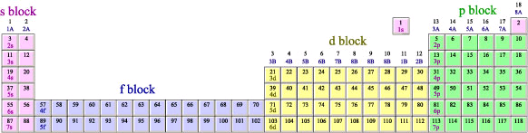

Each type of orbital (s, p, d, and f) is represented by a separate block as shown above.
(Aside: s, p, d and f come from the spectral lines created by each element: sharp, principle, diffuse, and fundamental.)

Before writing electron configurations, we should orient ourselves to the periodic table.

A Period goes across the table in rows. There are 7 periods.
A Group goes down each column.

- Examples of Electronic Configuration of some elements. Observe the periodic table above and match where they fall in the “blocks.”
  - Hydrogen 1s¹
  - Helium 1s²
  - Oxygen 1s² 2s² 2p⁴
  - Argon 1s² 2s² 2p⁶ 3s² 3p⁶

- Try the following:
  - Beryllium (Be)

  - Sodium (Na)

  - Magnesium (Mg)

  - Boron (B)

  - Fluorine (F)

  - Aluminum (Al)

  - Argon (Ar)

Element 118's electronic configuration would be:

1s² 2s² 2p⁶ 3s² 3p⁶ 4s²3d¹⁰ 4p⁶ 5s²4d¹⁰ 5p⁶ 6s²4f¹⁴ 5d¹⁰ 6p⁶ 7s²5f¹⁴ 6d¹⁰ 7p⁶

Now, you should say to yourself: “self, there must be an easier way”.
There is- It is based on the noble gasses (group 18). Instead of writing the whole configuration, one simply writes the next smaller noble gas in brackets, and then the remaining configuration. Thus, element 118's configuration becomes:

[Rn] 7s² 5f¹⁴ 6d¹⁰ 7p⁶

- Try the following using the next smaller noble gas notation:
  - Li, Na, K, Rb, Cs, Fr

  - F, Cl, Br, I, At

  - B, Al, Ga, In, Tl

  - Sc, Y, La, Ac

